|  |  |
| --- | --- |
| **EXP NO: 1** | **WRITE A HTML PROGRAM FOR CREATION OF WEBSITE USING FRAME, FORM, LINK AND TABLE** |
| **DATE: 23/1/25** |

**AIM:**

To write a html program for creation of forms links and tables

**ALGORITHM:**

**Step 1:** Start the HTML document using <!DOCTYPE html> and open <html> and <head> tags. **Step 2:** Set the title of the webpage using the <title> tag inside <head>. **Step 3:** Open the <body> tag to begin adding visible content. **Step 4:** Create a form using the <form> tag with action and method attributes.  
**Step 5:** Add input fields such as <input type="text"> and <input type="email"> inside the form. **Step 6:** Include a submit button using <input type="submit">. **Step 7:** Create hyperlinks using <a href="URL">Link Text</a>.  
**Step 8:** Design a table using <table>, and add rows with <tr>, headers with <th>, and data with <td>. **Step 9:** Close all opened tags properly: </form>, </table>, </body>, and </html>.  
  
**SOURCE CODE:**<!DOCTYPE html>

<html>

<head>

<title>HTML Forms, Links, and Tables Example</title>

<style>

body {

font-family: Arial, sans-serif;

margin: 20px;

}

table {

border-collapse: collapse;

width: 60%;

margin-top: 20px;

}

table, th, td {

border: 1px solid #444;

}

th, td {

padding: 10px;

text-align: left;

}

form {

margin-bottom: 20px;

}

</style>

</head>

<body>

<h2>Registration Form</h2>

<form action="#" method="post">

<label for="name">Name:</label><br>

<input type="text" id="name" name="name" required><br><br>

<label for="email">Email:</label><br>

<input type="email" id="email" name="email" required><br><br>

<input type="submit" value="Register">

</form>

<h2>Useful Links</h2>

<ul>

<li><a href="https://www.w3schools.com" target="_blank">Visit W3Schools</a></li>

<li><a href="https://www.mozilla.org" target="_blank">Visit Mozilla</a></li>

</ul>

<h2>Participant Table</h2>

<table>

<tr>

<th>S.No</th>

<th>Name</th>

<th>Email</th>

</tr>

<tr>

<td>1</td>

<td>Alice Johnson</td>

<td>alice@example.com</td>

</tr>

<tr>

<td>2</td>

<td>Bob Smith</td>

<td>bob@example.com</td>

</tr>

</table>

</body>

</html>

**OUTPUT:**

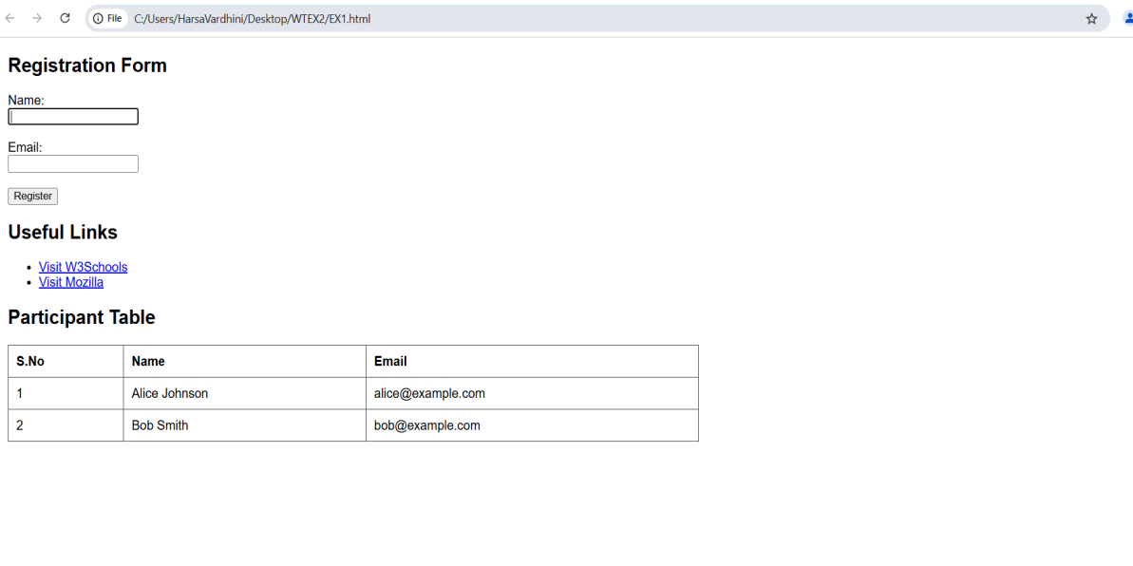  
**RESULT:**

  Thus, the HTML webpage containing hyperlinks, forms, and tables is successfully created.The functionalities were implemented and verified with proper structure and formatting using basic HTML tags.

|  |  |
| --- | --- |
| **EXP NO: 2** | **DESIGN A WEBSITE USING HTML WITH BASIC TEXT FORMATTING AND IMAGES** |
| **DATE: 30/1/25** |

**AIM:**

To create a website using html to create a basic textformatting and images

**ALGORITHM:**

**Step 1:** Start the HTML document using <!DOCTYPE html> and open <html>, <head>, and <body> tags. **Step 2:** Set the character encoding and viewport settings using <meta> tags inside <head>. **Step 3:** Add the title of the webpage using the <title> tag. **Step 4:** Create a main heading using the <h1> tag. **Step 5:** Add multiple paragraphs using <p>, and apply formatting tags like <b>, <i>, <u>, <mark>, <del>, and <small>. **Step 6:** Insert a subheading using <h2> and display an image using the <img> tag with src and alt attributes. **Step 7:** Create another subheading and add a hyperlink using the <a> tag with href and target="_blank". **Step 8:** Add a bulleted list using the <ul> tag with items inside <li> tags. **Step 9:** Close all opened tags properly, including </body> and </html>.  
  
**SOURCE CODE:**<!DOCTYPE html>

<html lang="en">

<head>

    <meta charset="UTF-8">

    <meta name="viewport" content="width=device-width, initial-scale=1.0">

    <title>Welcome to My Creative Webpage</title>

</head>

<body>

    <!-- Heading -->

    <h1>Discover the Beauty of Simplicity</h1>

    <!-- Paragraphs with text formatting -->

    <p><b>Welcome</b> to a space where creativity meets simplicity. This webpage showcases how <i>beautiful design</i> can be achieved with <u>basic HTML elements</u>.</p>

    <p>Every great journey begins with a single step. Just like <mark>every well-crafted webpage</mark> starts with a structured layout and a creative touch.</p>

    <p><b><i>Innovation</i></b> is not about complexity; it's about making things <small>meaningful</small> and <b>impactful</b>. <del>Overthinking</del> is unnecessary—just start building!</p>

    <!-- Image -->

    <h2>A Glimpse of Elegance</h2>

    <img src="https://tse3.mm.bing.net/th?id=OIP.DXTzA53g5h_MlYhHIt7IEwHaFj&pid=Api&P=0&h=180" alt="Beautiful Landscape">

    <!-- Hyperlink -->

    <h2>Stay Inspired</h2>

    <p>Explore more amazing content at <a href="https://www.example.com" target="_blank">Example Website</a> and keep learning!</p>

    <!-- List -->

    <h2>Keys to a Stunning Webpage</h2>

    <ul>

        <li>Minimalism - Less is more.</li>

        <li>Typography - Choose fonts wisely.</li>

        <li>Visual Balance - Keep it clean and structured.</li>

    </ul>

</body>

</html>

**OUTPUT:**

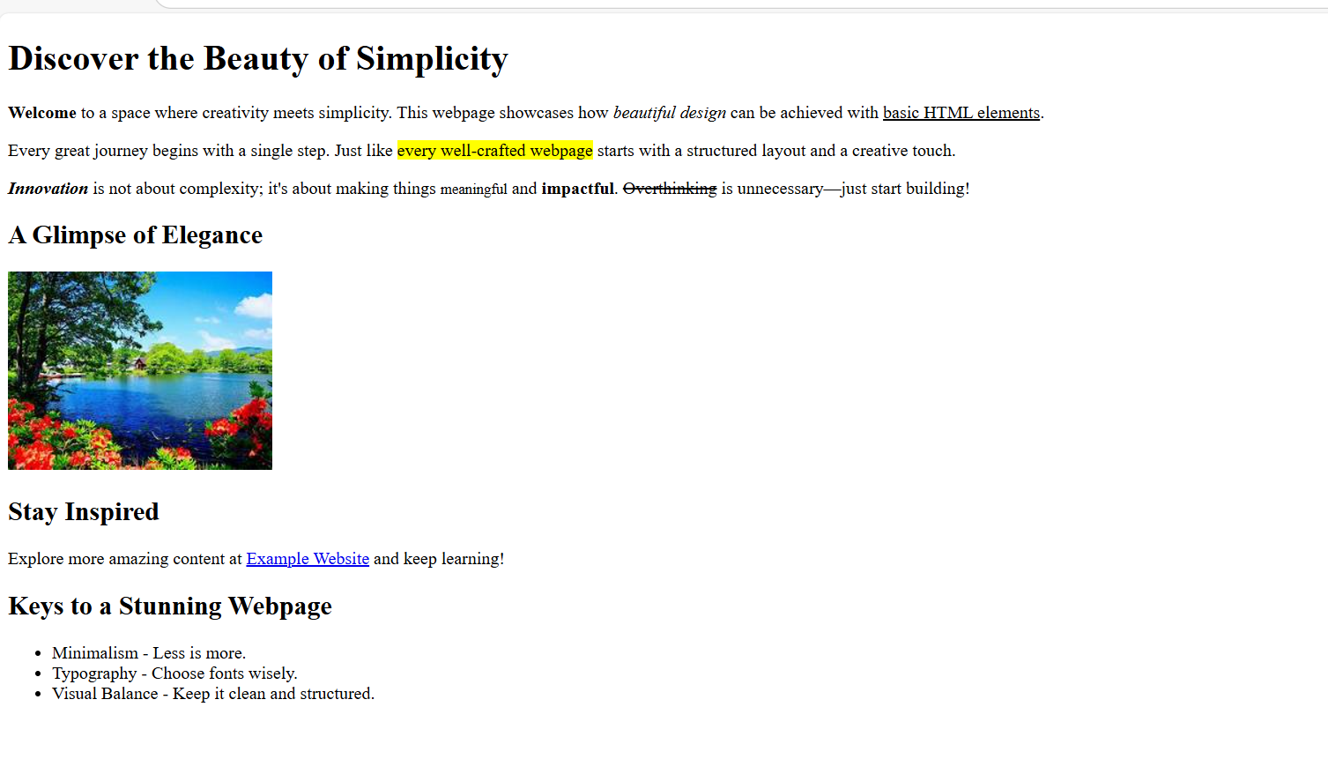

**RESULT:**

   Thus, the HTML webpage title is successfully created. It demonstrates the use of text formatting tags, image embedding, hyperlinks, and unordered lists to build a clean and creative webpage layout using basic HTML elements.

|  |  |
| --- | --- |
| **EXP NO: 3** | **CREATE A WEBPAGE WITH IMAGE MAP AND HOTSPOTS TO SHOW** |
| **DATE: 30/1/25** |

**i)To embed an image in a webpage**

**ii)To fix the hotspot**

**iii)Show all the related information when the hotspot is clicked**

**AIM:**

To create a webpage using HTML5 that embeds an image with interactive hotspots and displays related information upon clicking them.

**ALGORITHM:**

**Step 1:** Start the HTML document with <!DOCTYPE html> and open <html> and <head> tags. **Step 2:** Set the character encoding and viewport using <meta> tags inside the <head> tag. **Step 3:** Define the title of the webpage with <title> tag. **Step 4:** Inside the <body>, use the <img> tag to embed the image and define the usemap attribute linking it to the image map. **Step 5:** Define an image map using the <map> tag with a unique name and add <area> tags inside it. **Step 6:** Set the coordinates of each hotspot using the coords attribute of the <area> tag and specify the href attribute to link to the related information.  
**Step 7:** Ensure the image map’s defined regions are clickable and properly configured to display or redirect information when clicked.  
**Step 8:** Close all the tags properly with </body> and </html>.

**SOURCE CODE:**<!DOCTYPE html>

<html lang="en">

<head>

    <meta charset="UTF-8">

    <meta name="viewport" content="width=device-width, initial-scale=1.0">

    <title>Image Map</title>

</head>

<body>

    <h1>Interactive World Map</h1>

    <p>Click on different continents to learn more.</p>

    <!-- Image with an image map -->

    <img src="https://thumbs.dreamstime.com/b/high-resolution-world-map-landforms-detailed-satellite-view-earth-its-global-elements-image-furnished-nasa-87502492.jpg" usemap="#worldmap" width="800" alt="World Map">

    <!-- Image Map Definition -->

    <map name="worldmap">

        <!-- Europe -->

        <area shape="rect" coords="350,80,450,180" href="https://en.wikipedia.org/wiki/Europe" target="_blank" alt="Europe">

        <!-- Asia -->

        <area shape="rect" coords="460,80,660,280" href="https://en.wikipedia.org/wiki/Asia" target="_blank" alt="Asia">

        <!-- Africa -->

        <area shape="rect" coords="370,200,500,380" href="https://en.wikipedia.org/wiki/Africa" target="_blank" alt="Africa">

        <!-- North America -->

        <area shape="rect" coords="50,50,250,250" href="https://en.wikipedia.org/wiki/North_America" target="_blank" alt="North America">

        <!-- South America -->

        <area shape="rect" coords="180,280,300,450" href="https://en.wikipedia.org/wiki/South_America" target="_blank" alt="South America">

        <!-- Australia -->

        <area shape="rect" coords="650,320,780,450" href="https://en.wikipedia.org/wiki/Australia" target="_blank" alt="Australia">

    </map>

    <p>Clicking on any hotspot will take you to Wikipedia for more details about that continent.</p>

</body>

</html>

**OUTPUT:**

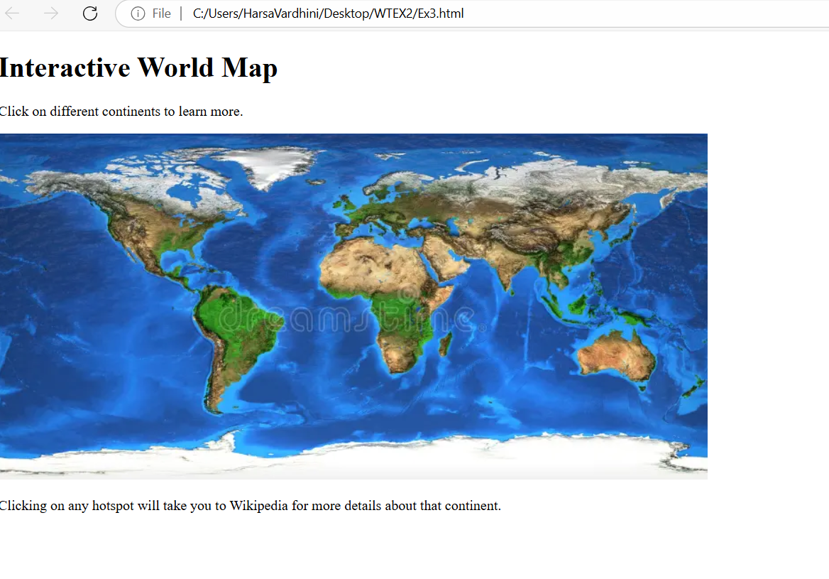

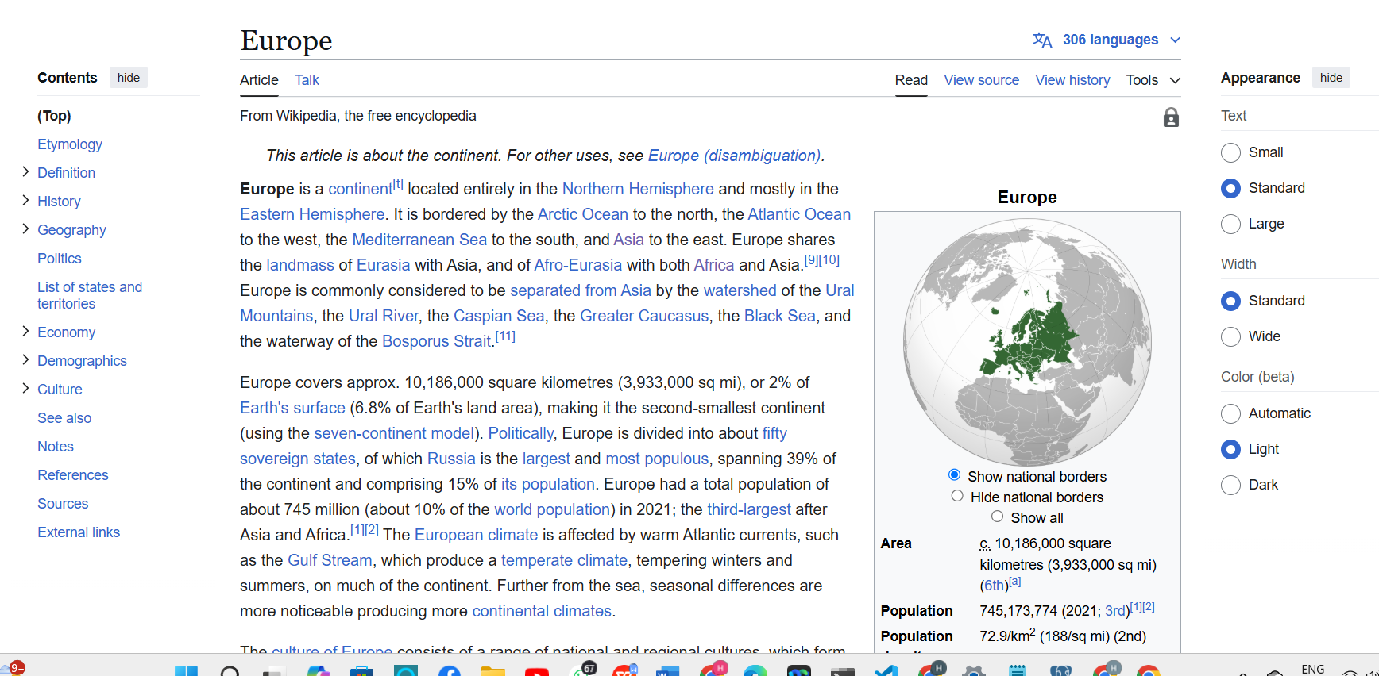

**RESULT:**

Thus, the HTML5 webpage with an embedded image map is successfully created.The interactive hotspots were defined and linked to show related information when clickeproviding a seamless user experience with clickable areas on the image.

|  |  |
| --- | --- |
| **EXP NO: 4** | **CREATE A WEBPAGE WITH ALL TYPES OF CSS** |
| **DATE: 06/02/25** |

**AIM:**

To design a professional webpage using **HTML5** and **CSS** (internal, external, and inline) that showcases various CSS features including styling, layout, and responsiveness.

**ALGORITHM:**

**Step 1:** Start the HTML document with <!DOCTYPE html> and open <html>, <head>, and <body> tags. **Step 2:** Set metadata such as character encoding and viewport using <meta> tags inside the <head>. **Step 3:** Define the title of the webpage using the <title> tag. **Step 4:** Link an external CSS file using the <link rel="stylesheet"> tag for global styles.  
**Step 5:** Add internal CSS inside <style> tags to customize specific elements like headings and spans. **Step 6:** Create a header section using <header> with a <h1> and <p> for the main title and subtitle. **Step 7:** Embed an image in the hero section using <img> and apply inline CSS for responsive sizing. **Step 8:** Overlay text on the hero image using a <div> with styled <h2> and <p> elements. **Step 9:** Add a content section with <h2> and <p> tags, using <span class="highlight"> to emphasize text. **Step 10:** Build a features section with multiple <div class="feature-box"> blocks describing key CSS topics. **Step 11:** Create a footer using <footer> and include a copyright notice. **Step 12:** Close all open tags (</body>, </html>) to complete the webpage structure.

**SOURCE CODE:**

<!DOCTYPE html>

<html lang="en">

<head>

    <meta charset="UTF-8">

    <meta name="viewport" content="width=device-width, initial-scale=1.0">

    <title>Professional CSS Webpage</title>

    <!-- External CSS -->

    <link rel="stylesheet" href="stylesex4.css">

    <!-- Internal CSS -->

    <style>

        h2 {

            color: #2a2a2b;

            text-align: center;

            margin-top: 30px;

            font-size: 28px;

        }

        .highlight {

            background-color: yellow;

            padding: 5px;

            font-weight: bold;

        }

    </style>

</head>

<body>

    <!-- Header Section -->

    <header>

        <h1>Welcome to the World of CSS</h1>

        <p>Mastering CSS for Modern Web Development</p>

    </header>

    <!-- Hero Section with Inline CSS -->

    <section class="hero">

        <img src="https://img.freepik.com/premium-photo/suspension-bridge-travel-nature-scenery-building_1417-264.jpg" alt="Web Design" style="width: 100%; height: auto;">

        <div class="hero-text">

            <h2 style="color: white; font-size: 35px;">CSS: The Heart of Web Styling</h2>

            <p style="color: white;">Discover how CSS enhances design, responsiveness, and animations.</p>

            <a href="#" class="btn">Explore More</a>

        </div>

    </section>

    <!-- Content Section -->

    <section class="content">

        <h2>Why Learn CSS?</h2>

        <p>CSS (Cascading Style Sheets) allows you to design professional web pages by <span class="highlight">adding styles, animations, and responsiveness</span>.</p>

        <p>With CSS, you can create visually appealing layouts and improve user experience.</p>

    </section>

    <!-- Features Section -->

    <section class="features">

        <div class="feature-box">

            <h3>CSS Selectors</h3>

            <p>Target elements with different selectors for precise styling.</p>

        </div>

        <div class="feature-box">

            <h3>CSS Grid & Flexbox</h3>

            <p>Create dynamic layouts with ease.</p>

        </div>

        <div class="feature-box">

            <h3>CSS Animations</h3>

            <p>Enhance UI with animations and transitions.</p>

        </div>

    </section>

    <!-- Footer -->

    <footer>

        <p>&copy; 2025 Professional CSS Webpage </p>

    </footer>

</body>

</html>

**OUTPUT:**



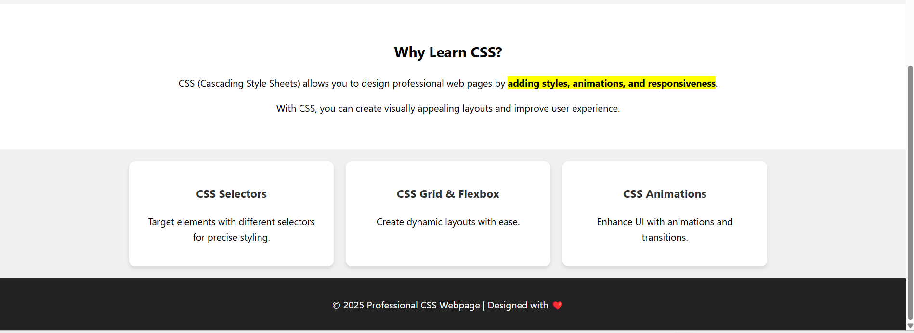

**RESULT:**

Thus, the professional HTML5 webpage integrated with internal, external, and inline CSS is successfully created.The webpage demonstrates structured layout, custom styling, and responsiveness, showcasing core concepts of CSS effectively.

|  |  |
| --- | --- |
| **EXP NO: 5** | **DESIGN A SCIENTIFIC CALCULATOR USING HTML, CSS, AND JAVASCRIPT** |
| **DATE: 13/02/25** |

**AIM:**

To design a Scientific Calculator using HTML, CSS, and JavaScript.

**ALGORITHM:**

**Step 1:** Create the HTML structure with a display and calculator buttons.  
**Step 2:** Style the calculator layout and buttons using CSS for better user interface.  
**Step 3:** Implement appendToDisplay(value) to add clicked button values to the input field.  
**Step 4:** Implement clearDisplay() to reset the input display when needed.   
**Step 5:** Implement calculateResult() to evaluate the mathematical expression.   
**Step 6:** Use try-catch block in calculateResult() to handle invalid expressions.  
**Step 7:** Add scientific functions like sqrt, pow, sin, cos, tan, log, exp, and pi.  
**Step 8:** Assign onclick events to all calculator buttons to trigger JavaScript functions.

**SOURCE CODE:**

<!DOCTYPE html>

<html lang="en">

<head>

<meta charset="UTF-8">

<meta name="viewport" content="width=device-width, initial-scale=1.0">

<title>Document</title>

<style>

body {

display: flex;

justify-content: center;

align-items: center;

height: 100vh;

background-color: #f4f4f4;

}

.calculator {

width: 300px;

background: #fff;

padding: 20px;

border-radius: 10px;

box-shadow: 0 0 10px rgba(0, 0, 0, 0.1);

text-align: center;

}

input {

width: 100%;

height: 50px;

text-align: right;

font-size: 1.5em;

margin-bottom: 10px;

}

.buttons {

display: grid;

grid-template-columns: repeat(4, 1fr);

gap: 5px;

}

button {

height: 50px;

font-size: 1.2em;

border: none;

cursor: pointer;

background: #eee;

border-radius: 5px;

}

button:active {

background: #ddd;

}

.equal {

background: #28a745;

color: white;

}

.clear {

background: #dc3545;

color: white;

}

</style>

</head>

<body>

<div class="calculator">

<input type="text" id="display" disabled>

<div class="buttons">

<button onclick="clearDisplay()" class="clear">C</button>

<button onclick="appendToDisplay('(')">(</button>

<button onclick="appendToDisplay(')')">)</button>

<button onclick="appendToDisplay('/')">/</button>

<button onclick="appendToDisplay('7')">7</button>

<button onclick="appendToDisplay('8')">8</button>

<button onclick="appendToDisplay('9')">9</button>

<button onclick="appendToDisplay('*')">*</button>

<button onclick="appendToDisplay('4')">4</button>

<button onclick="appendToDisplay('5')">5</button>

<button onclick="appendToDisplay('6')">6</button>

<button onclick="appendToDisplay('-')">-</button>

<button onclick="appendToDisplay('1')">1</button>

<button onclick="appendToDisplay('2')">2</button>

<button onclick="appendToDisplay('3')">3</button>

<button onclick="appendToDisplay('+')">+</button>

<button onclick="appendToDisplay('0')">0</button>

<button onclick="appendToDisplay('.')">.</button>

<button onclick="calculateResult()" class="equal">=</button>

<button onclick="appendToDisplay('Math.sqrt(')">√</button>

<button onclick="appendToDisplay('Math.pow(')">x^y</button>

<button onclick="appendToDisplay('Math.sin(')">sin</button>

<button onclick="appendToDisplay('Math.cos(')">cos</button>

<button onclick="appendToDisplay('Math.tan(')">tan</button>

<button onclick="appendToDisplay('Math.log(')">log</button>

<button onclick="appendToDisplay('Math.exp(')">e^x</button>

<button onclick="appendToDisplay('Math.PI')">π</button>

</div>

</div>

</body>

<script>

function appendToDisplay(value){

document.getElementById("display").value+=value;

}

function clearDisplay(){

document.getElementById("display").value="";

}

function calculateResult(){

try{

document.getElementById("display").value= eval(document.getElementById("display").value);

}

catch(e){

alert("Invalid Expression");

clearDisplay();

}

}

</script>

</html>

**OUTPUT:**

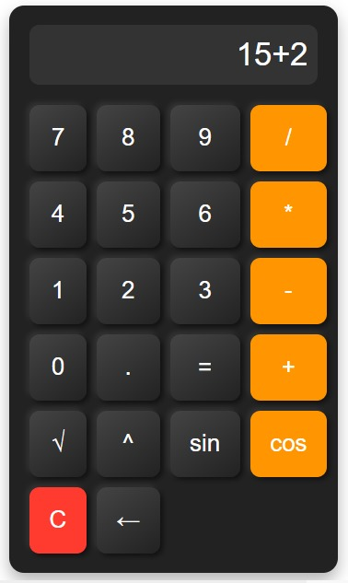

**RESULT:**

Thus, a scientific calculator is designed using JavaScript successfully and verified.

|  |  |
| --- | --- |
| **EXP NO:** **6** | **DESIGN A REGISTRATION FORM USING HTML, CSS, AND JAVASCRIPT VALIDATION(REGULAR EXPRESSION)** |
| **DATE:** **20/2/25** |

**AIM:**

To design a Registration Form using HTML, CSS (Bootstrap), and JavaScript validation.

**ALGORITHM:**

**Step 1:** Create the HTML structure with input fields for name, email, mobile, password, and confirm password.  
**Step 2:** Use Bootstrap and custom CSS to style the form and improve user interface.  
**Step 3:** Extract Head Size as X (independent variable) and Brain Weight as y (dependent variable).  
**Step 4:** Use regular expressions to validate name, email, mobile number, and password formats.  
**Step 5:** Check if password and confirm password fields match.  
**Step 6:** Display corresponding error messages for invalid inputs dynamically.  
**Step 7:** Prevent form submission if any validation fails and allow it if all inputs are valid.

**SOURCE CODE:**

<!DOCTYPE html>

<html lang="en">

<head>

<meta charset="UTF-8">

<meta name="viewport" content="width=device-width, initial-scale=1.0">

<title>Registration Form</title>

<link href="https://cdn.jsdelivr.net/npm/bootstrap@5.3.0/dist/css/bootstrap.min.css" rel="stylesheet">

<style>

body {

background-color: #f4f4f4;

font-family: Arial, sans-serif;

}

.container {

max-width: 450px;

background: #fff;

padding: 20px;

border-radius: 8px;

box-shadow: 0 0 10px rgba(0, 0, 0, 0.1);

margin-top: 50px;

}

.error {

color: red;

font-size: 14px;

}

</style>

</head>

<body>

<div class="container">

<h3 class="text-center">Registration Form</h3>

<form id="regForm" onsubmit="return validateForm()">

<div class="mb-3">

<label class="form-label">Full Name</label>

<input type="text" class="form-control" id="name">

<span class="error" id="nameError"></span>

</div>

<div class="mb-3">

<label class="form-label">Email</label>

<input type="email" class="form-control" id="email">

<span class="error" id="emailError"></span>

</div>

<div class="mb-3">

<label class="form-label">Mobile Number</label>

<input type="text" class="form-control" id="mobile">

<span class="error" id="mobileError"></span>

</div>

<div class="mb-3">

<label class="form-label">Password</label>

<input type="password" class="form-control" id="password">

<span class="error" id="passwordError"></span>

</div>

<div class="mb-3">

<label class="form-label">Confirm Password</label>

<input type="password" class="form-control" id="confirmPassword">

<span class="error" id="confirmPasswordError"></span>

</div>

<button type="submit" class="btn btn-primary w-100">Register</button>

</form>

</div>

<script>

function validateForm() {

let valid = true;

let name = document.getElementById("name").value.trim();

let email = document.getElementById("email").value.trim();

let mobile = document.getElementById("mobile").value.trim();

let password = document.getElementById("password").value;

let confirmPassword = document.getElementById("confirmPassword").value;

let nameRegex = /^[A-Za-z\s]{3,}$/;

let emailRegex = /^[a-zA-Z0-9._%+-]+@[a-zA-Z0-9.-]+\.[a-zA-Z]{2,}$/;

let mobileRegex = /^[6-9]\d{9}$/;

let passwordRegex = /^(?=.*[A-Za-z])(?=.*\d).{6,}$/;

document.getElementById("nameError").innerText = nameRegex.test(name) ? "" : "Name must be at least 3 letters";

document.getElementById("emailError").innerText = emailRegex.test(email) ? "" : "Invalid email format";

document.getElementById("mobileError").innerText = mobileRegex.test(mobile) ? "" : "Enter a valid 10-digit mobile number";

document.getElementById("passwordError").innerText = passwordRegex.test(password) ? "" : "Min 6 chars with at least one letter & number";

document.getElementById("confirmPasswordError").innerText = password === confirmPassword ? "" : "Passwords do not match";

return nameRegex.test(name) && emailRegex.test(email) && mobileRegex.test(mobile) && passwordRegex.test(password) && password === confirmPassword;

}

</script>

<script src="https://cdn.jsdelivr.net/npm/bootstrap@5.3.0/dist/js/bootstrap.bundle.min.js"></script>

</body>

</html>

**OUTPUT:**

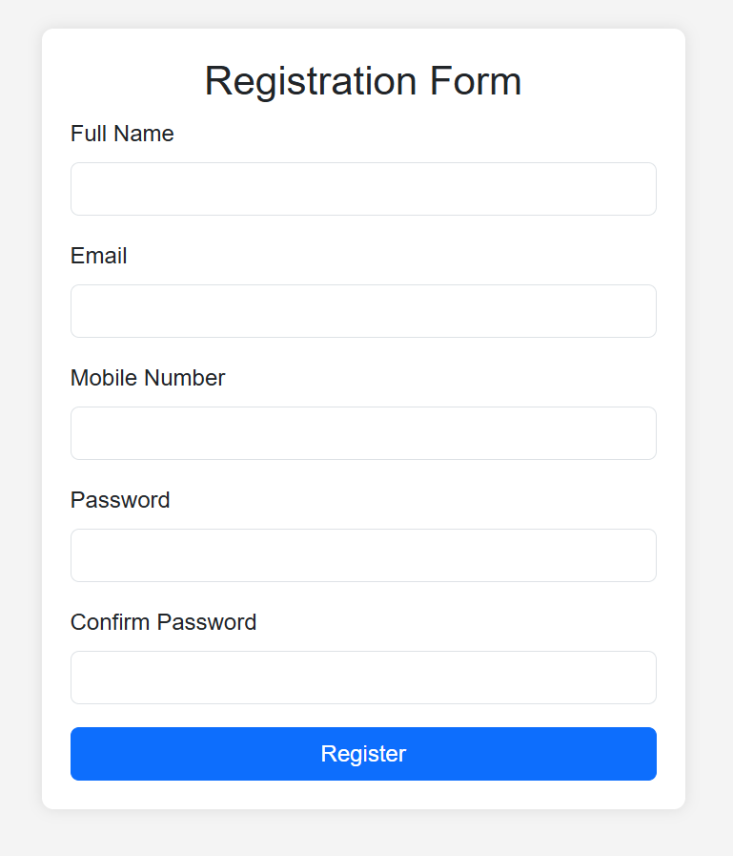

**RESULT:**

Thus, a registration form is designed using HTML,CSS and JavaScript successfully and verified.

|  |  |
| --- | --- |
| **EXP NO: 7** | **A RESPONSIVE WEBPAGE USING BOOTSTRAP** |
| **DATE:** **27/02/25** |

**AIM:**

To design a fully responsive and modern web page using Bootstrap 5 and Font Awesome with smooth animations and an elegant layout.

**ALGORITHM:**

**Step 1:** Start with the HTML5 boilerplate structure  
**Step 2:** Link Bootstrap CSS and Font Awesome icons from CDN  
**Step 3:** Design a navigation bar using Bootstrap's navbar component.  
**Step 4:** Create a hero section with a background image and animated welcome text.  
**Step 5:** Build a features section using Bootstrap cards to showcase highlights.  
**Step 6:** Create an image gallery using a Bootstrap grid layout with hover effects.  
**Step 7:** Add a contact section with a call-to-action button linked to an email.  
**Step 8:** Design a footer with social media icons and copyright information.  
**Step 9:** Use Bootstrap's utility classes and custom CSS for styling, hover effects, and responsiveness.  
**Step 10:** Link Bootstrap JavaScript at the bottom to enable collapsible navbar and other components.

**SOURCE CODE:**

<!DOCTYPE html>

<html lang="en">

<head>

<meta charset="UTF-8" />

<meta name="viewport" content="width=device-width, initial-scale=1" />

<title>Enhanced Responsive Web Page</title>

<link href="https://cdn.jsdelivr.net/npm/bootstrap@5.3.0/dist/css/bootstrap.min.css" rel="stylesheet">

<link href="https://cdnjs.cloudflare.com/ajax/libs/font-awesome/6.4.0/css/all.min.css" rel="stylesheet">

<style>

body {

font-family: 'Segoe UI', sans-serif;

scroll-behavior: smooth;

background-color: #f8f9fa;

}

.navbar {

box-shadow: 0 2px 5px rgba(0, 0, 0, 0.1);

}

.hero {

background: url('https://images.unsplash.com/photo-1519389950473-47ba0277781c') no-repeat center center/cover;

color: white;

padding: 120px 20px;

text-align: center;

animation: fadeIn 2s ease-in-out;

}

@keyframes fadeIn {

from { opacity: 0; transform: translateY(20px); }

to { opacity: 1; transform: translateY(0); }

}

.card:hover {

transform: translateY(-5px);

transition: transform 0.3s ease;

}

.feature-icon {

font-size: 2.5rem;

color: #0d6efd;

}

.gallery img {

width: 100%;

height: 250px;

object-fit: cover;

border-radius: 8px;

transition: transform 0.3s ease;

}

.gallery img:hover {

transform: scale(1.05);

}

.footer {

background-color: #343a40;

color: #fff;

padding: 30px 0;

}

.social-icons i {

font-size: 1.5rem;

margin: 0 10px;

color: white;

transition: color 0.3s;

}

.social-icons i:hover {

color: #0d6efd;

}

</style>

</head>

<body>

<!-- Navbar -->

<nav class="navbar navbar-expand-lg navbar-dark bg-primary sticky-top">

<div class="container">

<a class="navbar-brand" href="#">MySite</a>

<button class="navbar-toggler" type="button" data-bs-toggle="collapse" data-bs-target="#navbarNav">

<span class="navbar-toggler-icon"></span>

</button>

<div class="collapse navbar-collapse justify-content-end" id="navbarNav">

<ul class="navbar-nav">

<li class="nav-item"><a class="nav-link active" href="#home">Home</a></li>

<li class="nav-item"><a class="nav-link" href="#features">Features</a></li>

<li class="nav-item"><a class="nav-link" href="#gallery">Gallery</a></li>

<li class="nav-item"><a class="nav-link" href="#contact">Contact</a></li>

</ul>

</div>

</div>

</nav>

<!-- Hero Section -->

<section id="home" class="hero text-white">

<div class="container">

<h1 class="display-4 fw-bold">Welcome to My Beautiful Website</h1>

<p class="lead">Fully responsive. Smooth, modern design with animations and rich visuals.</p>

<a href="#features" class="btn btn-light mt-3">Explore Features</a>

</div>

</section>

<!-- Features Section -->

<section id="features" class="py-5">

<div class="container">

<h2 class="text-center mb-5">Amazing Features</h2>

<div class="row g-4">

<div class="col-md-4">

<div class="card text-center p-3 shadow-sm h-100">

<div class="card-body">

<i class="fas fa-laptop-code feature-icon mb-3"></i>

<h5 class="card-title">Responsive Design</h5>

<p class="card-text">Adapts beautifully to mobile, tablet, and desktop screens.</p>

</div>

</div>

</div>

<div class="col-md-4">

<div class="card text-center p-3 shadow-sm h-100">

<div class="card-body">

<i class="fas fa-magic feature-icon mb-3"></i>

<h5 class="card-title">Modern Animations</h5>

<p class="card-text">Smooth, eye-catching transitions for a sleek experience.</p>

</div>

</div>

</div>

<div class="col-md-4">

<div class="card text-center p-3 shadow-sm h-100">

<div class="card-body">

<i class="fas fa-bolt feature-icon mb-3"></i>

<h5 class="card-title">Fast & Lightweight</h5>

<p class="card-text">Minimal and optimized code for faster performance.</p>

</div>

</div>

</div>

</div>

</div>

</section>

<!-- Gallery Section -->

<section id="gallery" class="py-5 bg-light">

<div class="container">

<h2 class="text-center mb-5">Image Gallery</h2>

<div class="row g-4 gallery">

<div class="col-md-4"><img src="./alexa.avif" width="600" height="400" alt="Gallery Image"></div>

<div class="col-md-4"><img src="./coding.avif" width="600" height="400" alt="Gallery Image"></div>

<div class="col-md-4"><img src="./ai.webp" width="600" height="400" alt="Gallery Image"></div>

</div>

</div>

</section>

<!-- Contact Section -->

<section id="contact" class="py-5">

<div class="container text-center">

<h2 class="mb-4">Get in Touch</h2>

<p>Have questions or want to work together? Email me at <a href="mailto:hansi1122012@gmail.com">hansi1122012@gmail.com</a></p>

<a href="mailto:hansi1122012@gmail.com" class="btn btn-primary mt-2">Contact Now</a>

</div>

</section>

<!-- Footer -->

<footer class="footer text-center">

<div class="container">

<div class="social-icons mb-3">

<a href="#"><i class="fab fa-facebook-f"></i></a>

<a href="#"><i class="fab fa-twitter"></i></a>

<a href="#"><i class="fab fa-instagram"></i></a>

<a href="#"><i class="fab fa-github"></i></a>

</div>

<p class="mb-0">&copy; 2025 MySite. All rights reserved.</p>

</div>

</footer>

<!-- Bootstrap + Font Awesome -->

<script src="https://cdn.jsdelivr.net/npm/bootstrap@5.3.0/dist/js/bootstrap.bundle.min.js"></script>

</body>

</html>

**OUTPUT:**

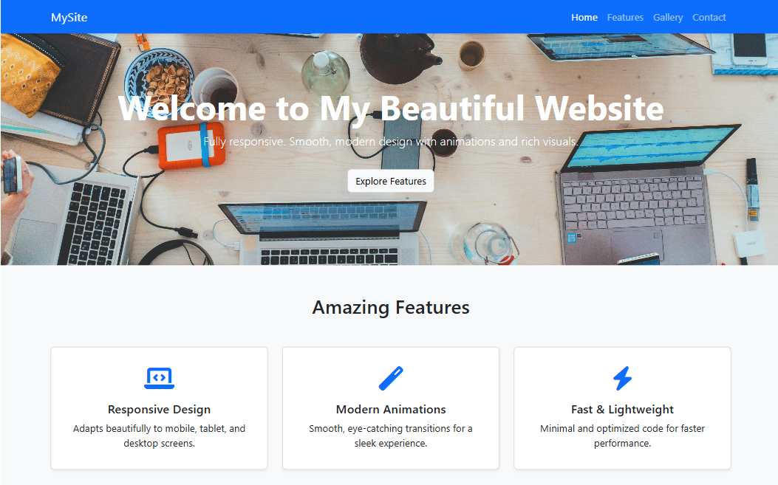

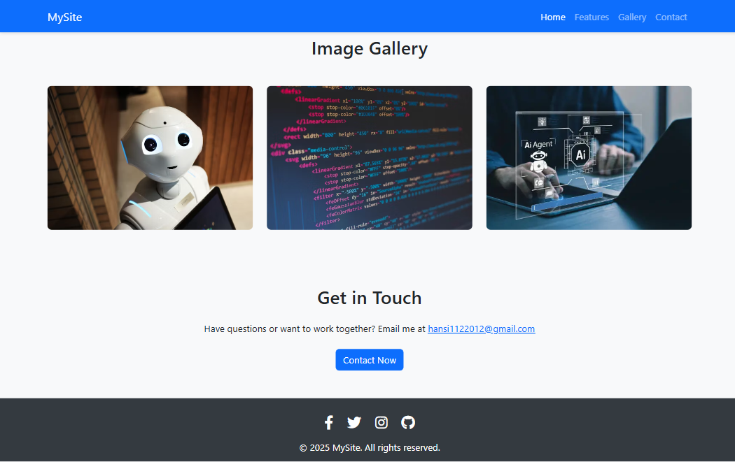

**RESULT:**

Thus, a fully responsive and visually appealing web page was successfully designed using Bootstrap 5 and verified.

|  |  |
| --- | --- |
| **EXP NO: 8** | **A RESPONSIVE WEB PAGE USING BOOTSTRAP'S GRID SYSTEM** |
| **DATE: 06/03/25** |

**AIM:**

To design a responsive web page using Bootstrap's grid system for adaptive layout.

**ALGORITHM:**

**Step 1:** Set up basic HTML structure with meta tags for responsiveness.  
**Step 2:** Include Bootstrap CSS and JS libraries.  
**Step 3:** Create a header with title and description.  
**Step 4:** Define a container for grid-based content.  
**Step 5:** Add a row with two columns for an image-text section.  
**Step 6:** Add a row with three equal-width columns for cards.  
**Step 7:** Add a row with four equal-width columns for smaller blocks.  
**Step 8:** Include footer with copyright information.  
**Step 9:** Test responsiveness across different screen sizes.

**SOURCE CODE:**

<!DOCTYPE html>

<html lang="en">

<head>

<meta charset="UTF-8" />

<meta name="viewport" content="width=device-width, initial-scale=1" />

<title>Bootstrap Grid Page</title>

<link href="https://cdn.jsdelivr.net/npm/bootstrap@5.3.0/dist/css/bootstrap.min.css" rel="stylesheet">

<style>

body {

font-family: 'Segoe UI', sans-serif;

}

.header {

background-color: #007bff;

color: white;

padding: 40px 0;

text-align: center;

}

.img-fluid {

border-radius: 8px;

}

.card:hover {

transform: translateY(-5px);

transition: 0.3s ease;

}

</style>

</head>

<body>

<!-- Header -->

<div class="header">

<h1>Bootstrap Grid System</h1>

<p>Responsive layout using rows and columns</p>

</div>

<!-- Grid Section -->

<div class="container py-5">

<!-- Row 1 -->

<div class="row mb-4">

<div class="col-md-6">

<img src="./ai.webp" width="600" height="400" alt="Tech Image" class="img-fluid">

</div>

<div class="col-md-6 d-flex align-items-center">

<div>

<h3>Responsive Columns</h3>

<p>This is a 2-column layout using Bootstrap’s grid. On smaller screens, it stacks vertically.</p>

</div>

</div>

</div>

<!-- Row 2 (3-column cards) -->

<div class="row text-center">

<div class="col-md-4 mb-4">

<div class="card shadow-sm h-100">

<div class="card-body">

<h5 class="card-title">Column One</h5>

<p class="card-text">This column spans 4/12 of the row on medium+ screens.</p>

</div>

</div>

</div>

<div class="col-md-4 mb-4">

<div class="card shadow-sm h-100">

<div class="card-body">

<h5 class="card-title">Column Two</h5>

<p class="card-text">Bootstrap handles spacing and responsiveness beautifully.</p>

</div>

</div>

</div>

<div class="col-md-4 mb-4">

<div class="card shadow-sm h-100">

<div class="card-body">

<h5 class="card-title">Column Three</h5>

<p class="card-text">Cards stay side by side or stack depending on screen width.</p>

</div>

</div>

</div>

</div>

<!-- Row 3 (4 columns) -->

<div class="row text-center">

<div class="col-sm-6 col-lg-3 mb-4">

<div class="p-3 bg-light border rounded">1/4 Width</div>

</div>

<div class="col-sm-6 col-lg-3 mb-4">

<div class="p-3 bg-light border rounded">1/4 Width</div>

</div>

<div class="col-sm-6 col-lg-3 mb-4">

<div class="p-3 bg-light border rounded">1/4 Width</div>

</div>

<div class="col-sm-6 col-lg-3 mb-4">

<div class="p-3 bg-light border rounded">1/4 Width</div>

</div>

</div>

</div>

<!-- Footer -->

<footer class="text-center py-4 bg-dark text-white">

&copy; 2025 Bootstrap Grid Demo

</footer>

<!-- Bootstrap Script -->

<script src="https://cdn.jsdelivr.net/npm/bootstrap@5.3.0/dist/js/bootstrap.bundle.min.js"></script>

</body>

</html>

**OUTPUT:**





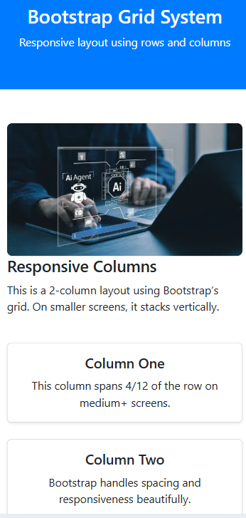 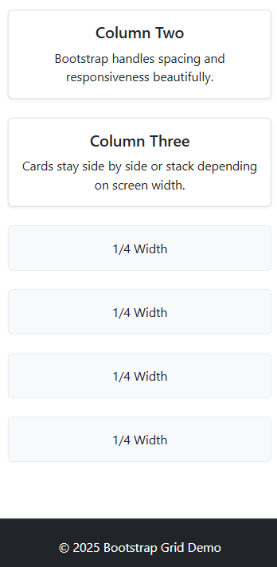 

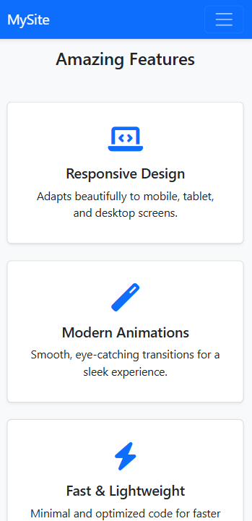 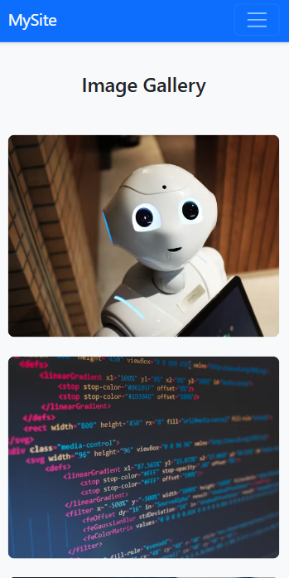 

**RESULT:**

Thus, a responsive web page using bootstrap’s grid system is implemented successfully.

|  |  |
| --- | --- |
| **EXP NO: 9** | **DESIGN A WEBPAGE WITH DROPDOWN, NAVIGATION BAR AND PAGINATION** |
| **DATE: 06/03/25** |

**AIM:**

To design a webpage with Dropdown, Navigation bar and Pagination.

**ALGORITHM:**

**Step 1:** Create a responsive HTML structure using Bootstrap 4 layout.  
**Step 2:** Add a dark-themed Bootstrap navbar with brand name and toggler. **Step 3:** Insert navbar links including Home, About, and a dropdown for Services. **Step 4:** Define dropdown items under Services using Bootstrap dropdown classes.  
**Step 5:** Add a container with welcome heading and paragraph content. **Step 6:** Insert Bootstrap pagination component with Previous, numbered pages, and Next. **Step 7:** Include Bootstrap and jQuery CDN links for styling and interactivity. **Step 8:** Add JavaScript to dynamically switch active pagination and update content.  
**Step 9:** Test navbar toggle, dropdown, and pagination functionality on various screen sizes.  
**Step 10**: Style and organize the layout using Bootstrap utility classes for clean design.

**SOURCE CODE:**

<!DOCTYPE html>

<html lang="en">

<head>

<meta charset="UTF-8">

<title>Perfect Webpage</title>

<meta name="viewport" content="width=device-width, initial-scale=1">

<link rel="stylesheet" href="https://maxcdn.bootstrapcdn.com/bootstrap/4.5.2/css/bootstrap.min.css">

<style>

body {

background-color: #f4f6f8;

font-family: 'Segoe UI', sans-serif;

}

.navbar {

box-shadow: 0 2px 6px rgba(0,0,0,0.1);

}

.item-card {

border: 1px solid #dee2e6;

border-radius: 10px;

padding: 20px;

background: white;

margin-bottom: 20px;

transition: 0.3s;

}

.item-card:hover {

box-shadow: 0 4px 12px rgba(0,0,0,0.1);

}

.pagination {

justify-content: center;

}

footer {

background: #343a40;

color: white;

padding: 20px 0;

text-align: center;

margin-top: 50px;

}

</style>

</head>

<body>

<!-- Navigation Bar -->

<nav class="navbar navbar-expand-lg navbar-dark bg-dark">

<a class="navbar-brand" href="#">MySite</a>

<button class="navbar-toggler" type="button" data-toggle="collapse" data-target="#navbarNav">

<span class="navbar-toggler-icon"></span>

</button>

<div class="collapse navbar-collapse" id="navbarNav">

<ul class="navbar-nav mr-auto">

<li class="nav-item active"><a class="nav-link" href="#">Home</a></li>

<li class="nav-item"><a class="nav-link" href="#">About</a></li>

<li class="nav-item dropdown">

<a class="nav-link dropdown-toggle" href="#" id="servicesDropdown" role="button" data-toggle="dropdown">

Services

</a>

<div class="dropdown-menu">

<a class="dropdown-item" href="#">Design</a>

<a class="dropdown-item" href="#">Development</a>

<a class="dropdown-item" href="#">SEO</a>

</div>

</li>

<li class="nav-item"><a class="nav-link" href="#">Contact</a></li>

</ul>

</div>

</nav>

<div class="container mt-5">

<h3 class="mb-4 text-center">Our Portfolio (Paginated Items)</h3>

<div id="item-list" class="row">

</div>

<nav>

<ul class="pagination" id="pagination">

</ul>

</nav>

</div>

<footer>

<div class="container">

<p>© 2025 MySite. All rights reserved.</p>

</div>

</footer>

<script src="https://code.jquery.com/jquery-3.5.1.slim.min.js"></script>

<script src="https://cdn.jsdelivr.net/npm/bootstrap@4.5.2/dist/js/bootstrap.bundle.min.js"></script>

<script>

const items = Array.from({ length: 24 }, (_, i) => `Item ${i + 1}`);

const itemsPerPage = 6;

let currentPage = 1

function renderItems() {

const start = (currentPage - 1) * itemsPerPage;

const end = start + itemsPerPage;

const currentItems = items.slice(start, end);

const itemList = document.getElementById('item-list');

itemList.innerHTML = '';

currentItems.forEach(item => {

const col = document.createElement('div');

col.className = 'col-md-4';

col.innerHTML = `

<div class="item-card">

<h5>${item}</h5>

<p>This is a short description for ${item}. Explore more about our awesome work.</p>

</div>`;

itemList.appendChild(col);

});

}

function renderPagination() {

const totalPages = Math.ceil(items.length / itemsPerPage);

const pagination = document.getElementById('pagination');

pagination.innerHTML = '';

// Previous Button

pagination.innerHTML += `

<li class="page-item ${currentPage === 1 ? 'disabled' : ''}">

<a class="page-link" href="#" onclick="changePage(${currentPage - 1})">Previous</a>

</li>`;

// Page Numbers

for (let i = 1; i <= totalPages; i++) {

pagination.innerHTML += `

<li class="page-item ${i === currentPage ? 'active' : ''}">

<a class="page-link" href="#" onclick="changePage(${i})">${i}</a>

</li>`;

}

// Next Button

pagination.innerHTML += `

<li class="page-item ${currentPage === totalPages ? 'disabled' : ''}">

<a class="page-link" href="#" onclick="changePage(${currentPage + 1})">Next</a>

</li>`;

}

function changePage(page) {

const totalPages = Math.ceil(items.length / itemsPerPage);

if (page >= 1 && page <= totalPages) {

currentPage = page;

renderItems();

renderPagination();

}

}

// Initial Load

renderItems();

renderPagination();

</script>

</body>

</html>

**OUTPUT:**

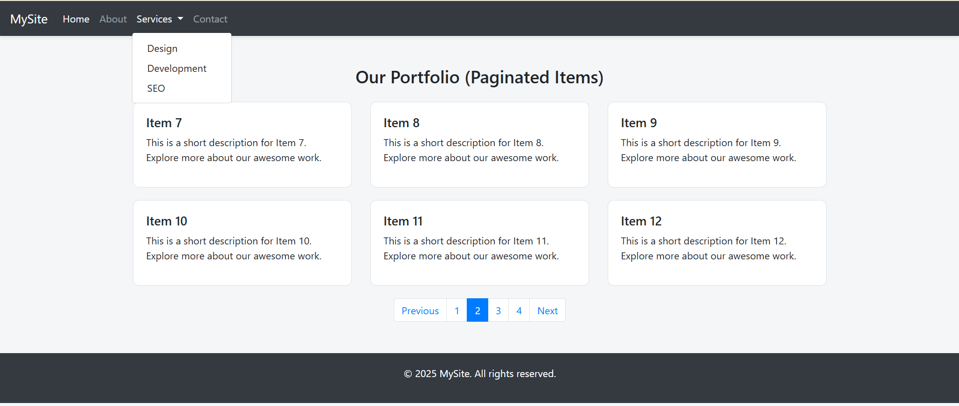

**RESULT:**

Thus, a webpage with Dropdown, Navigation bar and Pagination is designed successfully and verified.

|  |  |
| --- | --- |
| **EXP NO:** **10** | **DESIGN WEBPAGE USING JQUERY SELECTOR** |
| **DATE:** **27/03/25** |

**AIM:**

To design a web page using jQuery selector.

**ALGORITHM:**

**Step 1:** Create a structured HTML layout with headings, paragraphs, and div elements having various classes and attributes.

**Step 2:** Include jQuery library and Google Fonts via CDN in the <head>.

**Step 3:** Define CSS styles for layout, typography, buttons, and highlight effects.

**Step 4:** Add multiple buttons with unique IDs to trigger different selector actions.

**Step 5:** Wrap all content inside a styled container for better presentation.

**Step 6:** Use $(document).ready() to ensure jQuery runs after the DOM loads.

**Step 7:** Use jQuery element selector to toggle highlights on all paragraphs.

**Step 8:** Use class, attribute, child, and pseudo selectors (e.g., .note, [data-custom], :nth-child, :not) to target specific elements.

**Step 9:** Assign click event handlers to each button to apply corresponding visual effects.

**SOURCE CODE:**

<!DOCTYPE html>

<html lang="en">

<head>

    <meta charset="UTF-8">

    <title>Advanced jQuery Selectors Demo</title>

    <script src="https://code.jquery.com/jquery-3.6.0.min.js"></script>

    <link href="https://fonts.googleapis.com/css2?family=Roboto&display=swap" rel="stylesheet">

    <style>

        body {

            font-family: 'Roboto', sans-serif;

            background-color: #f8f9fa;

            padding: 40px;

        }

        .container {

            max-width: 800px;

            margin: auto;

            background-color: #ffffff;

            padding: 30px;

            border-radius: 10px;

            box-shadow: 0 0 15px rgba(0,0,0,0.1);

        }

        h2, h3 {

            color: #343a40;

            margin-bottom: 20px;

        }

        p, div {

            font-size: 17px;

            margin-bottom: 10px;

        }

        .note {

            color: #6c757d;

            font-style: italic;

        }

        .highlight {

            background-color: yellow;

            font-weight: bold;

        }

        .custom {

            color: darkgreen;

            font-weight: bold;

        }

        .special {

            color: red;

            font-weight: bold;

        }

        button {

            padding: 10px 15px;

            margin: 10px 5px;

            background-color: #007bff;

            color: white;

            border: none;

            border-radius: 4px;

            cursor: pointer;

        }

        button:hover {

            background-color: #0056b3;

        }

    </style>

</head>

<body>

<div class="container">

    <h2>Advanced jQuery Selector Demonstration</h2>

    <p>This is the first paragraph.</p>

    <p class="note">This is a note paragraph.</p>

    <div>This is a general div.</div>

    <div data-custom="true">This div has a custom data attribute.</div>

    <h3 class="note">This is a heading with class "note".</h3>

    <div class="note">This is another note div.</div>

    <button id="highlightParagraphs">Highlight Paragraphs</button>

    <button id="highlightNotes">Highlight Notes</button>

    <button id="highlightCustom">Highlight Data Attribute</button>

    <button id="highlightNth">Highlight Every 2nd Paragraph</button>

    <button id="highlightNotNote">Highlight Non-Note Paragraphs</button>

    <button id="highlightChild">Highlight First Child Div</button>

</div>

<script>

    $(document).ready(function(){

        // Element selector

        $("#highlightParagraphs").click(function(){

            $("p").toggleClass("highlight");

        });

        // Class selector

        $("#highlightNotes").click(function(){

            $(".note").toggleClass("highlight");

        });

        // Attribute selector

        $("#highlightCustom").click(function(){

            $("[data-custom]").toggleClass("custom");

        });

        // nth-child selector

        $("#highlightNth").click(function(){

            $("p:nth-child(2)").toggleClass("special");

        });

        // not selector

        $("#highlightNotNote").click(function(){

            $("p:not(.note)").toggleClass("highlight");

        });

        // child selector

        $("#highlightChild").click(function(){

            $("div:first-child").toggleClass("special");

        });

    });

</script>

</body>

</html>

**OUTPUT:**

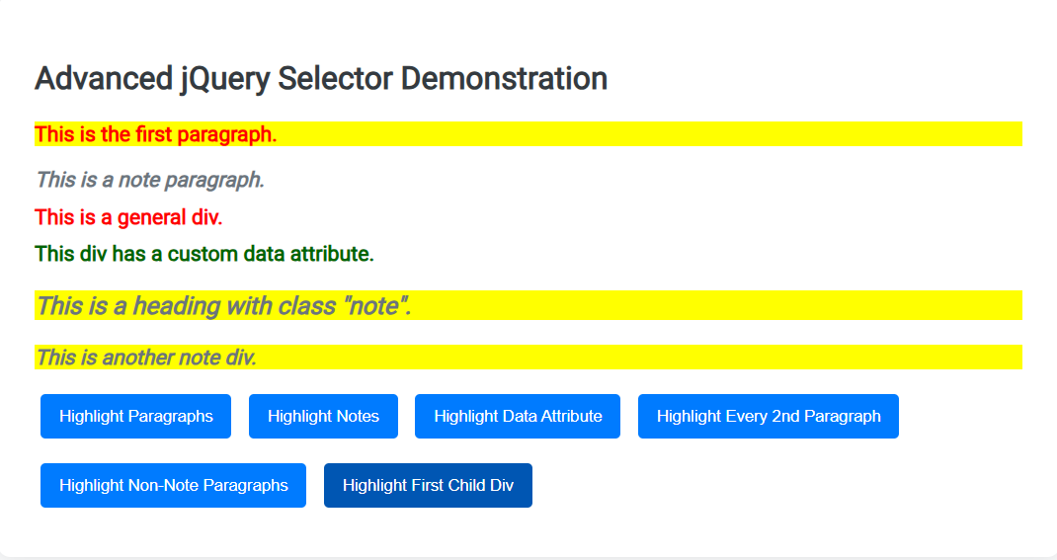

**RESULT:**

Thus, a web page using jQuery selector is designed successfully and verified.

|  |  |
| --- | --- |
| **EXP NO: 11** | **CREATE A SIMPLE WEB PAGE USING JQUERY EFFECTS** |
| **DATE:** **03/04/25** |

**AIM:**

To create a simple web page using jQuery Effects.

**ALGORITHM:**

**Step 1:** Start with a basic HTML structure including <head> and <body>.  
**Step 2:** Link jQuery and Google Fonts in the <head> section.  
**Step 3:** Style the layout using CSS for body, container, buttons, and effect box.  
**Step 4:** Create a centered container with a heading and multiple buttons for effects.  
**Step 5:** Add a <div> element (#effectBox) to show visual changes from jQuery.  
**Step 6:** Use $(document).ready() to initialize jQuery when the page is loaded.  
**Step 7:** Attach click() events to each button to trigger a specific jQuery effect like fadeToggle, slideUp, hide, show, etc.  
**Step 8:** Use animate() to apply combined width, height, and opacity transitions.  
**Step 9:** Use toggleClass() to switch styles dynamically for highlighting.

**SOURCE CODE:**

<!DOCTYPE html>

<html lang="en">

<head>

    <meta charset="UTF-8">

    <title>Advanced jQuery Effects</title>

    <script src="https://code.jquery.com/jquery-3.6.0.min.js"></script>

    <link href="https://fonts.googleapis.com/css2?family=Roboto&display=swap" rel="stylesheet">

    <style>

        body { font-family: 'Roboto', sans-serif;

            background: #f4f7fa;

            padding: 40px;

        }

        .container {

            max-width: 750px;

            margin: auto;

            background: #fff;

            padding: 30px;

            border-radius: 10px;

            box-shadow: 0 4px 15px rgba(0,0,0,0.1);

            text-align: center;

        }

        h2 { color: #333;

            margin-bottom: 25px;

        }

        button {

            margin: 10px;

            padding: 12px 20px;

            border: none;

            background-color: #007bff;

            color: #fff;

            border-radius: 6px;

            cursor: pointer;

            font-size: 15px;

            transition: 0.3s;

        }

        button:hover {

            background-color: #0056b3;

        }

        #effectBox {

            width: 100%;

            max-width: 500px;

            height: 150px;

            background: #d1ecf1;

            margin: 20px auto;

            padding: 20px;

            font-size: 18px;

            line-height: 1.5;

            border-radius: 8px;

            box-shadow: 0 4px 10px rgba(0,0,0,0.1);

            transition: all 0.4s ease-in-out;

        }

        .highlighted {

            background-color: #ffc107 !important;

            color: #000;

            transform: scale(1.05);

        }

    </style>

</head>

<body>

<div class="container">

    <h2>Advanced jQuery Effects</h2>

    <button id="fadeToggle">Fade Toggle</button>

    <button id="fadeIn">Fade In</button>

    <button id="fadeOut">Fade Out</button>

    <button id="slideToggle">Slide Toggle</button>

    <button id="slideUp">Slide Up</button>

    <button id="slideDown">Slide Down</button>

    <button id="hide">Hide</button>

    <button id="show">Show</button>

    <button id="toggle">Toggle</button>

    <button id="animateBtn">Animate</button>

    <button id="highlightBtn">Highlight Toggle</button>

    <div id="effectBox">

        This is a dynamic content box. Click any button above to try different effects!

    </div>

</div>

<script>

    $(document).ready(function(){

        $("#fadeToggle").click(function(){

            $("#effectBox").fadeToggle("slow");

        });

        $("#fadeIn").click(function(){

        $("#effectBox").fadeIn("slow");

        });

        $("#fadeOut").click(function(){

            $("#effectBox").fadeOut("slow");

        });

        $("#slideToggle").click(function(){

            $("#effectBox").slideToggle("slow");

        });

        $("#slideUp").click(function(){

            $("#effectBox").slideUp("slow");

        });

        $("#slideDown").click(function(){

            $("#effectBox").slideDown("slow");

        });

        $("#hide").click(function(){

            $("#effectBox").hide("slow");

        });

        $("#show").click(function(){

            $("#effectBox").show("slow");

        });

        $("#toggle").click(function(){

            $("#effectBox").toggle("slow");

        });

        $("#animateBtn").click(function(){

            $("#effectBox").animate({

                width: "toggle",

                height: "toggle",

                opacity: "toggle"

            }, 1000);

        });

        $("#highlightBtn").click(function(){

            $("#effectBox").toggleClass("highlighted");

        });

    });

</script>

</body>

</html>

**OUTPUT:**

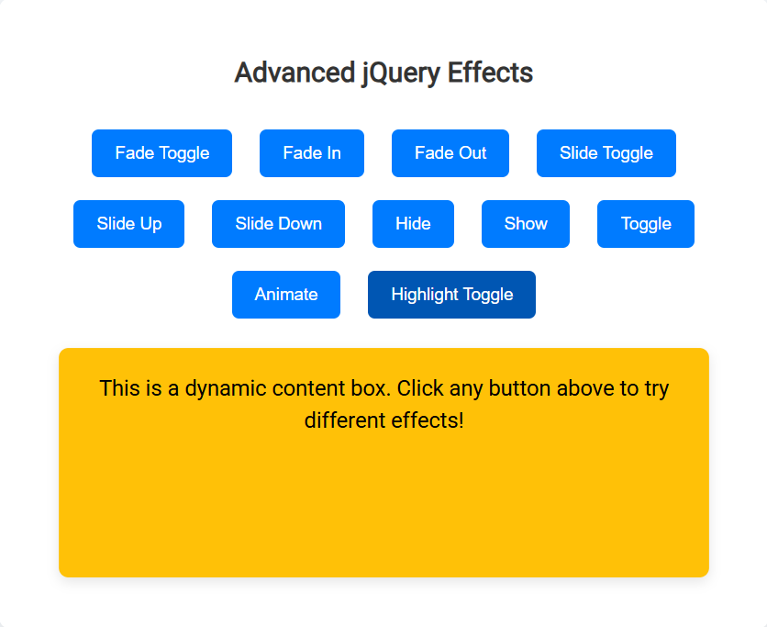

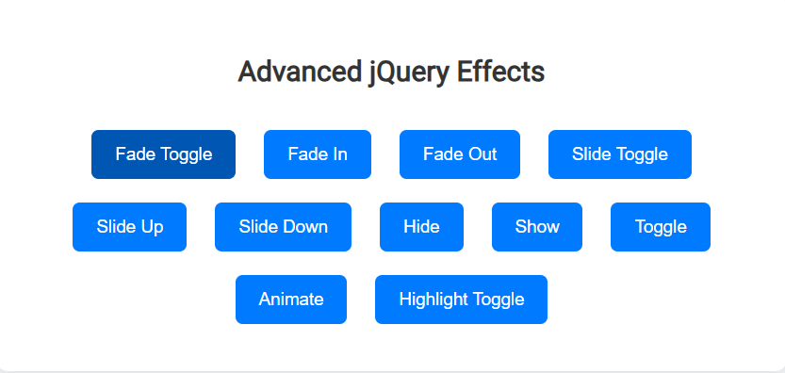

**RESULT:**

Thus, a simple web page was successfully designed using jQuery effects and verified.

|  |  |
| --- | --- |
| **EXP NO: 12** | **DESIGN A WEB PAGE TO CALCULATE FACTORIAL OF A NUMBER USING PHP** |
| **DATE: 10/04/25** |

**AIM:**

To design a web page to calculate factorial of a number using PHP.

**ALGORITHM:**

**Step 1:** Create an HTML form to accept a number as input from the user.  
**Step 2:** Set the form's method to POST and action to the same PHP file.  
**Step 3:** Check if the form is submitted using $_SERVER["REQUEST_METHOD"] == "POST".  
**Step 4:** Retrieve the input number using $_POST["num"].  
**Step 5:** Initialize a variable factorial to 1.  
**Step 6:** If the input number is negative, display an error message.  
**Step 7:** Otherwise, use a for loop to multiply numbers from 1 to the input number.  
**Step 8:** After the loop ends, display the calculated factorial result.  
**Step 9:** Embed the PHP code below the HTML form to process and display the result on the same page.

**SOURCE CODE:**

<!DOCTYPE html>

<html lang="en">

<head>

    <meta charset="UTF-8">

    <title>Factorial Calculator</title>

    <style>

        body {

            font-family: 'Segoe UI', sans-serif;

            background-color: #f0f8ff;

            display: flex;

            justify-content: center;

            align-items: center;

            height: 100vh;

        }

        .container {

            background-color: white;

            padding: 30px 40px;

            border-radius: 10px;

            box-shadow: 0 0 15px rgba(0,0,0,0.2);

            text-align: center;

            width: 350px;

        }

        h2 {

            color: #007bff;

            margin-bottom: 20px;

        }

        input[type="number"] {

            width: 80%;

            padding: 10px;

            margin-bottom: 15px;

            border-radius: 5px;

            border: 1px solid #ccc;

            font-size: 16px;

        }

        input[type="submit"] {

            background-color: #007bff;

            color: white;

            border: none;

            padding: 10px 20px;

            font-size: 16px;

            border-radius: 5px;

            cursor: pointer;

        }

        input[type="submit"]:hover {

            background-color: #0056b3;

        }

        .result {

            margin-top: 20px;

            font-size: 18px;

            font-weight: bold;

            color: green;

        }

        .error {

            color: red;

        }

    </style>

</head>

<body>

    <div class="container">

        <h2>Factorial Calculator</h2>

        <form method="post" action="">

            <input type="number" name="num" placeholder="Enter a number" required>

            <br>

            <input type="submit" value="Calculate">

        </form>

        <?php

        if ($_SERVER["REQUEST_METHOD"] == "POST") {

            $num = $_POST["num"];

            if (!is_numeric($num)) {

                echo "<div class='error'>Please enter a valid number.</div>";

            } elseif ($num < 0) {

                echo "<div class='error'>Factorial is not defined for negative numbers.</div>";

            } else {

                $factorial = 1;

                for ($i = 1; $i <= $num; $i++) {

                    $factorial *= $i;

                }

                echo "<div class='result'>Factorial of $num is $factorial</div>";

            }

        }

        ?>

    </div>

</body>

</html>

**OUTPUT:**





**RESULT:**

Thus, designing a web page to calculate factorial of a number using PHP has been executed successfully.

|  |  |
| --- | --- |
| **EXP NO: 13** | **CREATE A WEB PAGE TO PERFORM ARITHMETIC OPERATIONS USING PHP** |
| **DATE: 10/04/25** |

**AIM:**

To create a webpage to perform arithmetic operations using PHP.

**ALGORITHM:**

**Step 1:** Start  
**Step 2:** Display a form to input two numbers and select an operation (Add, Subtract, Multiply, Divide).  
**Step 3:** Wait for user to submit the form using the submit button.  
**Step 4:** Retrieve input values num1, num2, and operation from the form  
**Step 5:** Validate inputs to ensure both numbers are numeric  
**Step 6:** Use switch-case to perform the selected arithmetic operation  
**Step 7:** Handle division by zero if the operation is division  
**Step 8:** **Display the result** on the same page  
**Step 9:** End

**SOURCE CODE:**

<!DOCTYPE html>

<html lang="en">

<head>

<meta charset="UTF-8">

<title>Arithmetic Calculator</title>

<style>

body {

font-family: Arial, sans-serif;

background-color: #f4f6f9;

padding: 50px;

}

.calculator {

background: #fff;

padding: 30px;

max-width: 400px;

margin: auto;

border-radius: 10px;

box-shadow: 0 0 15px rgba(0,0,0,0.2);

}

h2 {

text-align: center;

margin-bottom: 20px;

color: #333;

}

input[type="number"], select {

width: 100%;

padding: 10px;

margin: 10px 0;

border: 1px solid #ccc;

border-radius: 5px;

}

input[type="submit"] {

background-color: #28a745;

color: white;

padding: 12px;

border: none;

width: 100%;

border-radius: 5px;

cursor: pointer;

}

input[type="submit"]:hover {

background-color: #218838;

}

.result {

margin-top: 20px;

text-align: center;

font-weight: bold;

color: #007bff;

}

.error {

color: red;

font-weight: bold;

text-align: center;

}

</style>

</head>

<body>

<div class="calculator">

<h2>Arithmetic Calculator</h2>

<form method="post" action="">

Number 1:

<input type="number" name="num1" step="any" required>

Number 2:

<input type="number" name="num2" step="any" required>

Operation:

<select name="operation" required>

<option value="">--Select Operation--</option>

<option value="add">Addition (+)</option>

<option value="sub">Subtraction (-)</option>

<option value="mul">Multiplication (×)</option>

<option value="div">Division (÷)</option>

</select>

<input type="submit" value="Calculate">

</form>

<?php

if ($_SERVER["REQUEST_METHOD"] == "POST") {

$num1 = $_POST["num1"];

$num2 = $_POST["num2"];

$op = $_POST["operation"];

if (!is_numeric($num1) || !is_numeric($num2)) {

echo "<div class='error'>Please enter valid numbers.</div>";

} else {

switch($op) {

case "add": $res = $num1 + $num2; break;

case "sub": $res = $num1 - $num2; break;

case "mul": $res = $num1 * $num2; break;

case "div":

if ($num2 != 0) {

$res = $num1 / $num2;

} else {

$res = "Cannot divide by zero";

}

break;

default: $res = "Invalid operation";

}

echo "<div class='result'>Result: $res</div>";

}

}

?>

</div>

</body>

</html>

**OUTPUT:**

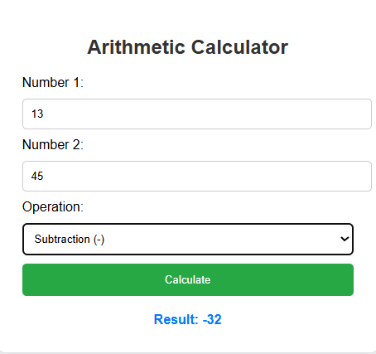

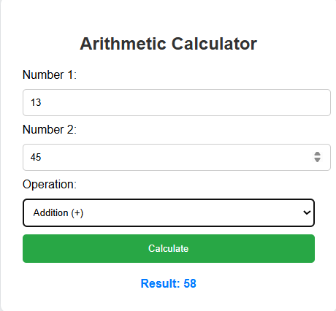

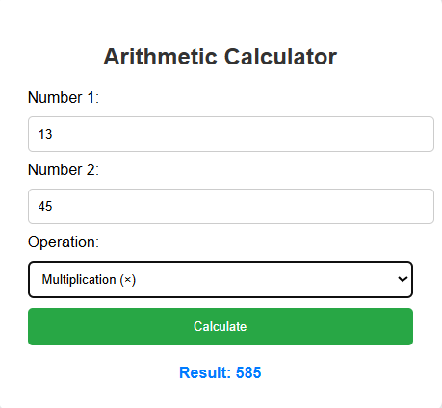

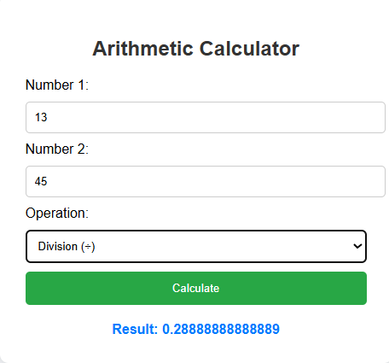

**RESULT:**

Thus, a webpage to perform arithmetic operations using PHP has been executed successfully.

|  |  |
| --- | --- |
| **EXP NO: 14** | **PHP PROGRAM USING REGULAR EXPRESSIONS** |
| **DATE: 17/04/25** |

**AIM:**

To design and implement a PHP-based web form that validates user inputs using regular expressions and logic checks.

**ALGORITHM:**

**Step 1:** Start the HTML form and accept input fields for username, DOB, mobile, Aadhar, password, PIN code, and PAN number.  
**Step 2:** On form submission, collect form data using the $_POST method in PHP.  
**Step 3:** Initialize an empty array to store validation error messages.  
**Step 4:** Validate the username using a regular expression to allow 4–15 characters (letters, digits, underscores).  
**Step 5:** Calculate the user's age from DOB and check if it is 18 or above.  
**Step 6:** Validate the mobile number to ensure it starts with 6–9 and is 10 digits long.  
**Step 7:** Validate the Aadhar number to ensure it has exactly 12 digits.  
**Step 8:** If no validation errors, display a success message; otherwise, display all error messages.

**SOURCE CODE:**

<!DOCTYPE html>

<html>

<head>

<title>Enhanced Form Validation</title>

<style>

body {

font-family: Arial;

padding: 20px;

}

.error {

color: red;

}

.success {

color: green;

}

</style>

</head>

<body>

<h2>User Registration Form</h2>

<form method="post">

Username: <input type="text" name="username"><br><br>

Date of Birth: <input type="date" name="dob"><br><br>

Mobile Number: <input type="text" name="mobile"><br><br>

Aadhar Number: <input type="text" name="aadhar"><br><br>

Password: <input type="password" name="password"><br><br>

PIN Code: <input type="text" name="pincode"><br><br>

PAN Number: <input type="text" name="pan"><br><br>

<input type="submit" name="submit" value="Submit">

</form>

<?php

if (isset($_POST['submit'])) {

$username = $_POST['username'];

$dob = $_POST['dob'];

$mobile = $_POST['mobile'];

$aadhar = $_POST['aadhar'];

$password = $_POST['password'];

$pincode = $_POST['pincode'];

$pan = $_POST['pan'];

$errors = [];

// Username (4-15 characters, letters, digits, _)

if (!preg_match('/^[a-zA-Z0-9_]{4,15}$/', $username)) {

$errors[] = "Invalid Username";

}

// DOB (age must be 18+)

$today = new DateTime();

$birthDate = new DateTime($dob);

$age = $today->diff($birthDate)->y;

if ($age < 18) {

$errors[] = "You must be at least 18 years old.";

}

// Mobile

if (!preg_match('/^[6-9]\d{9}$/', $mobile)) {

$errors[] = "Invalid Mobile Number";

}

// Aadhar

if (!preg_match('/^\d{12}$/', $aadhar)) {

$errors[] = "Invalid Aadhar Number";

}

// Password (min 6 chars, at least 1 letter and 1 number)

if (!preg_match('/^(?=.*[A-Za-z])(?=.*\d)[A-Za-z\d]{6,}$/', $password)) {

$errors[] = "Password must be at least 6 characters with letters and numbers";

}

// PIN Code

if (!preg_match('/^[1-9][0-9]{5}$/', $pincode)) {

$errors[] = "Invalid PIN Code";

}

// PAN Number

if (!preg_match('/^[A-Z]{5}[0-9]{4}[A-Z]{1}$/', $pan)) {

$errors[] = "Invalid PAN Number";

}

// Output

if (empty($errors)) {

echo "<p class='success'>All inputs are valid!</p>";

} else {

foreach ($errors as $error) {

echo "<p class='error'>$error</p>";

}

}

}

?>

</body>

</html>

**OUTPUT:**

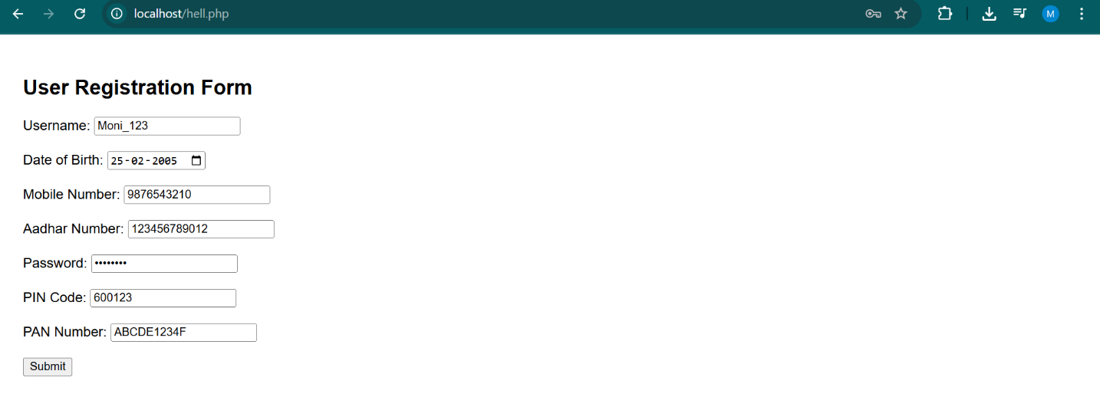

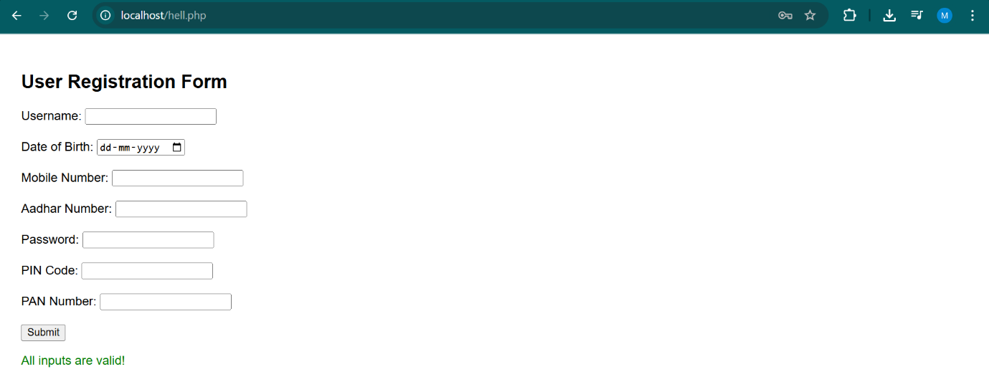

**RESULT:**

The PHP script successfully validates all user inputs and provides appropriate error or success messages based on the entered data.

|  |  |
| --- | --- |
| **EXP NO: 15** | **DEVELOP ANY APPLICATION USING PHP WITH MYSQL** |
| **DATE: 24/04/25** |

**AIM:**

To develop a book review system using PHP with MYSQL

**ALGORITHM:**

**Step 1:** Start

Initialize the system and load the home page

* Display navigation options: Login, Register, Browse Books, etc.

**Step 2:** User Registration/Login

* If new user: accept and validate registration details
* If existing user: authenticate credentials
* Redirect to dashboard based on role (Admin/Reader/Reviewer)

**Step 3:** Admin Module Execution

* Add, update, delete book listings and author profiles
* Approve or moderate submitted reviews
* Generate reports on books and user activity

**Step 4:** Reader/Reviewer Module Execution

* Browse and search for books using filters (genre, title, author)
* View book details and existing reviews
* Reviewers can submit or update reviews and ratings

**Step 5:** Review Management

* Accept review input, validate and store it in the database
* Update book’s average rating dynamically based on new reviews

**Step 6:** Feedback and Moderation

* Admin monitors reviews for inappropriate content
* Flagged reviews can be edited or removed

**Step 7:** End

* Logout and safely terminate session
* Close database connections and end the application

**SOURCE CODE:**

<!DOCTYPE html>

<html lang="en">

<head>

  <meta charset="UTF-8">

  <meta name="viewport" content="width=device-width, initial-scale=1.0">

  <title>Book Review System</title>

  <link rel="stylesheet" href="https://cdnjs.cloudflare.com/ajax/libs/font-awesome/6.4.0/css/all.min.css">

  <style>

    :root {

      --primary: #6366f1;

      --primary-dark: #4f46e5;

      --secondary: #e2e8f0;

      --text: #334155;

      --text-light: #64748b;

      --danger: #ef4444;

      --success: #22c55e;

      --warning: #f59e0b;

    }

    * {

      margin: 0;

      padding: 0;

      box-sizing: border-box;

      font-family: 'Inter', -apple-system, BlinkMacSystemFont, 'Segoe UI', Roboto, Oxygen, Ubuntu, Cantarell, sans-serif;

    }

    body {

      background-color: #f8fafc;

      color: var(--text);

      line-height: 1.6;

    }

    .container {

      max-width: 1200px;

      margin: 0 auto;

      padding: 0 1rem;

    }

    header {

      background-color: white;

      box-shadow: 0 1px 3px rgba(0, 0, 0, 0.1);

      position: sticky;

      top: 0;

      z-index: 10;

    }

    .navbar {

      display: flex;

      justify-content: space-between;

      align-items: center;

      padding: 1rem 0;

    }

    .logo {

      font-size: 1.5rem;

      font-weight: 700;

      color: var(--primary);

      display: flex;

      align-items: center;

      gap: 0.5rem;

    }

    .search-bar {

      flex: 1;

      margin: 0 2rem;

      position: relative;

    }

    .search-bar input {

      width: 100%;

      padding: 0.75rem 1rem 0.75rem 2.5rem;

      border-radius: 0.5rem;

      border: 1px solid var(--secondary);

      font-size: 0.875rem;

      background-color: #f1f5f9;

      transition: all 0.2s ease;

    }

    .search-bar input:focus {

      outline: none;

      background-color: white;

      border-color: var(--primary);

    }

    .search-icon {

      position: absolute;

      left: 0.75rem;

      top: 50%;

      transform: translateY(-50%);

      color: var(--text-light);

    }

    .nav-actions {

      display: flex;

      gap: 1rem;

      align-items: center;

    }

    .btn {

      padding: 0.6rem 1.2rem;

      border-radius: 0.5rem;

      border: none;

      font-weight: 500;

      cursor: pointer;

      font-size: 0.875rem;

      transition: all 0.2s ease;

      display: inline-flex;

      align-items: center;

      gap: 0.5rem;

    }

    .btn-primary {

      background-color: var(--primary);

      color: white;

    }

    .btn-primary:hover {

      background-color: var(--primary-dark);

    }

    .btn-outline {

      background-color: transparent;

      border: 1px solid var(--primary);

      color: var(--primary);

    }

    .btn-outline:hover {

      background-color: var(--primary);

      color: white;

    }

    .btn-danger {

      background-color: var(--danger);

      color: white;

    }

    .btn-danger:hover {

      background-color: #dc2626;

    }

    .main {

      padding: 2rem 0;

    }

    .section-title {

      display: flex;

      justify-content: space-between;

      align-items: center;

      margin-bottom: 1.5rem;

      border-bottom: 1px solid var(--secondary);

      padding-bottom: 0.75rem;

    }

    .section-title h2 {

      font-size: 1.5rem;

      font-weight: 600;

    }

    .dashboard-stats {

      display: grid;

      grid-template-columns: repeat(auto-fit, minmax(240px, 1fr));

      gap: 1.5rem;

      margin-bottom: 2rem;

    }

    .stat-card {

      background-color: white;

      padding: 1.5rem;

      border-radius: 0.5rem;

      box-shadow: 0 1px 3px rgba(0, 0, 0, 0.1);

      transition: transform 0.2s ease;

    }

    .stat-card:hover {

      transform: translateY(-5px);

    }

    .stat-card .number {

      font-size: 2rem;

      font-weight: 700;

      margin-bottom: 0.5rem;

      color: var(--primary);

    }

    .stat-card .label {

      font-size: 0.875rem;

      color: var(--text-light);

    }

    .book-list {

      display: grid;

      grid-template-columns: repeat(auto-fill, minmax(300px, 1fr));

      gap: 1.5rem;

    }

    .book-card {

      background-color: white;

      border-radius: 0.5rem;

      overflow: hidden;

      box-shadow: 0 1px 3px rgba(0, 0, 0, 0.1);

      transition: all 0.2s ease;

      display: flex;

      flex-direction: column;

    }

    .book-card:hover {

      transform: translateY(-5px);

      box-shadow: 0 10px 15px -3px rgba(0, 0, 0, 0.1);

    }

    .book-cover {

      height: 200px;

      overflow: hidden;

      position: relative;

      background-color: #e0e7ff;

      display: flex;

      align-items: center;

      justify-content: center;

    }

    .book-cover img {

      width: 100%;

      height: 100%;

      object-fit: cover;

    }

    .book-cover .default-cover {

      font-size: 4rem;

      color: var(--primary);

    }

    .book-info {

      padding: 1.5rem;

      flex: 1;

      display: flex;

      flex-direction: column;

    }

    .book-title {

      font-size: 1.25rem;

      font-weight: 600;

      margin-bottom: 0.5rem;

      line-height: 1.4;

    }

    .book-author {

      color: var(--text-light);

      font-size: 0.875rem;

      margin-bottom: 1rem;

    }

    .book-rating {

      display: flex;

      gap: 0.25rem;

      margin-bottom: 1rem;

    }

    .star {

      color: var(--warning);

    }

    .book-review {

      margin-bottom: 1rem;

      font-size: 0.875rem;

      overflow: hidden;

      display: -webkit-box;

      -webkit-line-clamp: 3;

      -webkit-box-orient: vertical;

      flex: 1;

    }

    .card-actions {

      display: flex;

      justify-content: space-between;

      margin-top: 1rem;

    }

    .card-actions button {

      padding: 0.5rem;

      border-radius: 0.25rem;

      border: none;

      background-color: transparent;

      cursor: pointer;

      transition: all 0.2s ease;

    }

    .card-actions button:hover {

      background-color: var(--secondary);

    }

    .read-more {

      color: var(--primary);

      text-decoration: none;

      font-weight: 500;

      font-size: 0.875rem;

      margin-top: 0.5rem;

      display: inline-block;

    }

    .book-tags {

      display: flex;

      flex-wrap: wrap;

      gap: 0.5rem;

      margin-bottom: 1rem;

    }

    .tag {

      background-color: #e0e7ff;

      color: var(--primary);

      padding: 0.25rem 0.75rem;

      border-radius: 9999px;

      font-size: 0.75rem;

      font-weight: 500;

    }

    .modal-overlay {

      position: fixed;

      top: 0;

      left: 0;

      right: 0;

      bottom: 0;

      background-color: rgba(0, 0, 0, 0.5);

      display: flex;

      align-items: center;

      justify-content: center;

      z-index: 20;

      opacity: 0;

      visibility: hidden;

      transition: all 0.3s ease;

    }

    .modal-overlay.active {

      opacity: 1;

      visibility: visible;

    }

    .modal {

      background-color: white;

      border-radius: 0.5rem;

      width: 90%;

      max-width: 600px;

      max-height: 90vh;

      overflow-y: auto;

      box-shadow: 0 25px 50px -12px rgba(0, 0, 0, 0.25);

      transform: translateY(20px);

      transition: transform 0.3s ease;

    }

    .modal-overlay.active .modal {

      transform: translateY(0);

    }

    .modal-header {

      padding: 1.5rem;

      border-bottom: 1px solid var(--secondary);

      display: flex;

      justify-content: space-between;

      align-items: center;

    }

    .modal-title {

      font-size: 1.25rem;

      font-weight: 600;

    }

    .modal-close {

      background: none;

      border: none;

      font-size: 1.5rem;

      cursor: pointer;

      color: var(--text-light);

      transition: color 0.2s ease;

    }

    .modal-close:hover {

      color: var(--text);

    }

    .modal-body {

      padding: 1.5rem;

    }

    .form-group {

      margin-bottom: 1.5rem;

    }

    .form-label {

      display: block;

      margin-bottom: 0.5rem;

      font-weight: 500;

      font-size: 0.875rem;

    }

    .form-control {

      width: 100%;

      padding: 0.75rem 1rem;

      border-radius: 0.5rem;

      border: 1px solid var(--secondary);

      font-size: 0.875rem;

      transition: all 0.2s ease;

    }

    .form-control:focus {

      outline: none;

      border-color: var(--primary);

      box-shadow: 0 0 0 3px rgba(99, 102, 241, 0.1);

    }

    textarea.form-control {

      min-height: 120px;

      resize: vertical;

    }

    .star-rating {

      display: flex;

      gap: 0.5rem;

      margin-top: 0.5rem;

    }

    .star-rating i {

      cursor: pointer;

      font-size: 1.5rem;

      color: #d1d5db;

      transition: color 0.2s ease;

    }

    .star-rating i.active {

      color: var(--warning);

    }

    .form-footer {

      display: flex;

      justify-content: flex-end;

      gap: 1rem;

      margin-top: 2rem;

    }

    .no-results {

      grid-column: 1 / -1;

      text-align: center;

      padding: 4rem 0;

      color: var(--text-light);

    }

    .no-results i {

      font-size: 3rem;

      margin-bottom: 1rem;

      display: block;

    }

    .filters {

      display: flex;

      flex-wrap: wrap;

      gap: 1rem;

      margin-bottom: 2rem;

      align-items: center;

    }

    .filter-group {

      display: flex;

      align-items: center;

      gap: 0.5rem;

    }

    .filter-label {

      font-size: 0.875rem;

      font-weight: 500;

    }

    .filter-select {

      padding: 0.5rem;

      border-radius: 0.25rem;

      border: 1px solid var(--secondary);

      background-color: white;

      font-size: 0.875rem;

      color: var(--text);

    }

    .pagination {

      display: flex;

      justify-content: center;

      margin-top: 2rem;

      gap: 0.5rem;

    }

    .pagination button {

      padding: 0.5rem 1rem;

      border-radius: 0.25rem;

      border: 1px solid var(--secondary);

      background-color: white;

      cursor: pointer;

      transition: all 0.2s ease;

    }

    .pagination button:hover:not(.active) {

      background-color: var(--secondary);

    }

    .pagination button.active {

      background-color: var(--primary);

      color: white;

      border-color: var(--primary);

    }

    .toast {

      position: fixed;

      bottom: 2rem;

      right: 2rem;

      max-width: 350px;

      background-color: white;

      border-radius: 0.5rem;

      box-shadow: 0 10px 15px -3px rgba(0, 0, 0, 0.1);

      padding: 1rem;

      z-index: 30;

      display: flex;

      align-items: center;

      gap: 1rem;

      transform: translateY(100px);

      opacity: 0;

      transition: all 0.3s ease;

    }

    .toast.active {

      transform: translateY(0);

      opacity: 1;

    }

    .toast-icon {

      font-size: 1.5rem;

    }

    .toast-success .toast-icon {

      color: var(--success);

    }

    .toast-error .toast-icon {

      color: var(--danger);

    }

    .toast-warning .toast-icon {

      color: var(--warning);

    }

    .toast-content {

      flex: 1;

    }

    .toast-title {

      font-weight: 600;

      margin-bottom: 0.25rem;

    }

    .toast-message {

      font-size: 0.875rem;

      color: var(--text-light);

    }

    .toast-close {

      background: none;

      border: none;

      cursor: pointer;

      color: var(--text-light);

      font-size: 1.25rem;

      transition: color 0.2s ease;

    }

    .toast-close:hover {

      color: var(--text);

    }

    .loading {

      position: fixed;

      top: 0;

      left: 0;

      right: 0;

      bottom: 0;

      background-color: rgba(255, 255, 255, 0.7);

      display: flex;

      align-items: center;

      justify-content: center;

      z-index: 40;

      opacity: 0;

      visibility: hidden;

      transition: all 0.3s ease;

    }

    .loading.active {

      opacity: 1;

      visibility: visible;

    }

    .spinner {

      width: 40px;

      height: 40px;

      border: 4px solid rgba(99, 102, 241, 0.1);

      border-radius: 50%;

      border-top-color: var(--primary);

      animation: spin 1s linear infinite;

    }

    @keyframes spin {

      to {

        transform: rotate(360deg);

      }

    }

    .modal-detail {

      padding: 0;

    }

    .book-detail {

      display: flex;

      flex-direction: column;

    }

    .book-detail-header {

      display: flex;

      gap: 1.5rem;

      padding: 1.5rem;

      border-bottom: 1px solid var(--secondary);

    }

    .book-detail-cover {

      width: 120px;

      height: 180px;

      flex-shrink: 0;

      background-color: #e0e7ff;

      display: flex;

      align-items: center;

      justify-content: center;

      border-radius: 0.25rem;

      overflow: hidden;

    }

    .book-detail-cover img {

      width: 100%;

      height: 100%;

      object-fit: cover;

    }

    .book-detail-cover .default-cover {

      font-size: 3rem;

      color: var(--primary);

    }

    .book-detail-info {

      flex: 1;

    }

    .book-detail-title {

      font-size: 1.5rem;

      font-weight: 600;

      margin-bottom: 0.5rem;

    }

    .book-detail-author {

      color: var(--text-light);

      margin-bottom: 1rem;

    }

    .book-detail-rating {

      display: flex;

      gap: 0.25rem;

      margin-bottom: 1rem;

    }

    .book-detail-meta {

      display: flex;

      gap: 1.5rem;

      margin-bottom: 1rem;

      font-size: 0.875rem;

    }

    .meta-item {

      display: flex;

      align-items: center;

      gap: 0.5rem;

      color: var(--text-light);

    }

    .book-detail-content {

      padding: 1.5rem;

    }

    .book-detail-section {

      margin-bottom: 2rem;

    }

    .book-detail-section h3 {

      font-size: 1.125rem;

      font-weight: 600;

      margin-bottom: 1rem;

      padding-bottom: 0.5rem;

      border-bottom: 1px solid var(--secondary);

    }

    .confirm-dialog {

      text-align: center;

      padding: 1rem;

    }

    .confirm-dialog p {

      margin-bottom: 2rem;

    }

    .confirm-dialog-actions {

      display: flex;

      justify-content: center;

      gap: 1rem;

    }

    @media (max-width: 768px) {

      .navbar {

        flex-direction: column;

        gap: 1rem;

      }

      .search-bar {

        margin: 1rem 0;

        width: 100%;

      }

      .book-detail-header {

        flex-direction: column;

      }

      .book-detail-cover {

        width: 100%;

        height: 200px;

      }

    }

  </style>

</head>

<body>

  <header>

    <div class="container">

      <nav class="navbar">

        <div class="logo">

          <i class="fas fa-book"></i>

          <span>BookReviews</span>

        </div>

        <div class="search-bar">

          <i class="fas fa-search search-icon"></i>

          <input type="text" id="search-input" placeholder="Search books by title, author, or genre...">

        </div>

        <div class="nav-actions">

          <button class="btn btn-primary" id="add-book-btn">

            <i class="fas fa-plus"></i>

            Add Review

          </button>

        </div>

      </nav>

    </div>

  </header>

  <main class="main">

    <div class="container">

      <div class="section-title">

        <h2>Book Review Dashboard</h2>

      </div>

      <div class="dashboard-stats">

        <div class="stat-card">

          <div class="number" id="total-books">0</div>

          <div class="label">Total Books</div>

        </div>

        <div class="stat-card">

          <div class="number" id="average-rating">0.0</div>

          <div class="label">Average Rating</div>

        </div>

        <div class="stat-card">

          <div class="number" id="recent-reviews">0</div>

          <div class="label">Reviews This Month</div>

        </div>

      </div>

      <div class="section-title">

        <h2>Your Book Collection</h2>

        <div class="filters">

          <div class="filter-group">

            <label class="filter-label" for="sort-select">Sort by:</label>

            <select id="sort-select" class="filter-select">

              <option value="date-desc">Date Added (Newest)</option>

              <option value="date-asc">Date Added (Oldest)</option>

              <option value="rating-desc">Rating (Highest)</option>

              <option value="rating-asc">Rating (Lowest)</option>

              <option value="title-asc">Title (A-Z)</option>

              <option value="title-desc">Title (Z-A)</option>

            </select>

          </div>

          <div class="filter-group">

            <label class="filter-label" for="filter-select">Filter by:</label>

            <select id="filter-select" class="filter-select">

              <option value="all">All Books</option>

              <option value="rating-5">5 Star Books</option>

              <option value="rating-4">4+ Star Books</option>

              <option value="recently-added">Recently Added</option>

            </select>

          </div>

        </div>

      </div>

      <div class="book-list" id="book-list">

        <!-- Books will be added here dynamically -->

      </div>

      <div class="pagination" id="pagination">

        <!-- Pagination will be added here dynamically -->

      </div>

    </div>

  </main>

  <!-- Modals -->

  <div class="modal-overlay" id="add-book-modal">

    <div class="modal">

      <div class="modal-header">

        <h3 class="modal-title">Add New Book Review</h3>

        <button class="modal-close" id="add-modal-close">&times;</button>

      </div>

      <div class="modal-body">

        <form id="add-book-form">

          <div class="form-group">

            <label class="form-label" for="book-title">Book Title *</label>

            <input type="text" id="book-title" class="form-control" required>

          </div>

          <div class="form-group">

            <label class="form-label" for="book-author">Author *</label>

            <input type="text" id="book-author" class="form-control" required>

          </div>

          <div class="form-group">

            <label class="form-label" for="book-cover">Cover Image URL (Optional)</label>

            <input type="url" id="book-cover" class="form-control">

          </div>

          <div class="form-group">

            <label class="form-label" for="book-genre">Genre</label>

            <input type="text" id="book-genre" class="form-control" placeholder="Fiction, Mystery, Romance, etc.">

          </div>

          <div class="form-group">

            <label class="form-label">Rating *</label>

            <div class="star-rating" id="add-rating">

              <i class="far fa-star" data-rating="1"></i>

              <i class="far fa-star" data-rating="2"></i>

              <i class="far fa-star" data-rating="3"></i>

              <i class="far fa-star" data-rating="4"></i>

              <i class="far fa-star" data-rating="5"></i>

            </div>

          </div>

          <div class="form-group">

            <label class="form-label" for="book-review">Your Review *</label>

            <textarea id="book-review" class="form-control" required placeholder="Share your thoughts about this book..."></textarea>

          </div>

          <div class="form-footer">

            <button type="button" class="btn btn-outline" id="cancel-add">Cancel</button>

            <button type="submit" class="btn btn-primary">Save Review</button>

          </div>

        </form>

      </div>

    </div>

  </div>

  <div class="modal-overlay" id="edit-book-modal">

    <div class="modal">

      <div class="modal-header">

        <h3 class="modal-title">Edit Book Review</h3>

        <button class="modal-close" id="edit-modal-close">&times;</button>

      </div>

      <div class="modal-body">

        <form id="edit-book-form">

          <input type="hidden" id="edit-book-id">

          <div class="form-group">

            <label class="form-label" for="edit-book-title">Book Title *</label>

            <input type="text" id="edit-book-title" class="form-control" required>

          </div>

          <div class="form-group">

            <label class="form-label" for="edit-book-author">Author *</label>

            <input type="text" id="edit-book-author" class="form-control" required>

          </div>

          <div class="form-group">

            <label class="form-label" for="edit-book-cover">Cover Image URL (Optional)</label>

            <input type="url" id="edit-book-cover" class="form-control">

          </div>

          <div class="form-group">

            <label class="form-label" for="edit-book-genre">Genre</label>

            <input type="text" id="edit-book-genre" class="form-control" placeholder="Fiction, Mystery, Romance, etc.">

          </div>

          <div class="form-group">

            <label class="form-label">Rating *</label>

            <div class="star-rating" id="edit-rating">

              <i class="far fa-star" data-rating="1"></i>

              <i class="far fa-star" data-rating="2"></i>

              <i class="far fa-star" data-rating="3"></i>

              <i class="far fa-star" data-rating="4"></i>

              <i class="far fa-star" data-rating="5"></i>

            </div>

          </div>

          <div class="form-group">

            <label class="form-label" for="edit-book-review">Your Review *</label>

            <textarea id="edit-book-review" class="form-control" required placeholder="Share your thoughts about this book..."></textarea>

          </div>

          <div class="form-footer">

            <button type="button" class="btn btn-outline" id="cancel-edit">Cancel</button>

            <button type="submit" class="btn btn-primary">Update Review</button>

          </div>

        </form>

      </div>

    </div>

  </div>

  <div class="modal-overlay" id="view-book-modal">

    <div class="modal">

      <div class="modal-header">

        <h3 class="modal-title">Book Details</h3>

        <button class="modal-close" id="view-modal-close">&times;</button>

      </div>

      <div class="modal-body modal-detail">

        <div class="book-detail" id="book-detail">

          <!-- Book details will be added here dynamically -->

        </div>

      </div>

    </div>

  </div>

  <div class="modal-overlay" id="confirm-delete-modal">

    <div class="modal">

      <div class="modal-header">

        <h3 class="modal-title">Confirm Deletion</h3>

        <button class="modal-close" id="confirm-modal-close">&times;</button>

      </div>

      <div class="modal-body">

        <div class="confirm-dialog">

          <p>Are you sure you want to delete this book review? This action cannot be undone.</p>

          <input type="hidden" id="delete-book-id">

          <div class="confirm-dialog-actions">

            <button class="btn btn-outline" id="cancel-delete">Cancel</button>

            <button class="btn btn-danger" id="confirm-delete">Delete</button>

          </div>

        </div>

      </div>

    </div>

  </div>

  <!-- Toast Notifications -->

  <div class="toast" id="toast">

    <div class="toast-icon">

      <i class="fas fa-check-circle"></i>

    </div>

    <div class="toast-content">

      <div class="toast-title" id="toast-title">Success!</div>

      <div class="toast-message" id="toast-message">Action completed successfully.</div>

    </div>

    <button class="toast-close" id="toast-close">&times;</button>

  </div>

  <!-- Loading Spinner -->

  <div class="loading" id="loading">

    <div class="spinner"></div>

  </div>

  <script>

    // Book review data store

    const BookReviewApp = {

      books: [],

      currentBookId: 1,

      currentRating: 0,

      editRating: 0,

      itemsPerPage: 6,

      currentPage: 1,

      searchTerm: '',

      sortOption: 'date-desc',

      filterOption: 'all',

      init() {

        // Load saved books from localStorage if available

        this.loadBooks();

        // Initialize UI

        this.updateStats();

        this.renderBooks();

        // Add event listeners

        this.addEventListeners();

      },

      loadBooks() {

        const savedBooks = localStorage.getItem('bookReviews');

        if (savedBooks) {

          this.books = JSON.parse(savedBooks);

          // Find the highest ID to ensure new books get unique IDs

          if (this.books.length > 0) {

            const maxId = Math.max(...this.books.map(book => book.id));

            this.currentBookId = maxId + 1;

          }

        } else {

          // Add sample data if no books exist

          this.addSampleBooks();

        }

      },

      addSampleBooks() {

        const sampleBooks = [

          {

            id: 1,

            title: "To Kill a Mockingbird",

            author: "Harper Lee",

            cover: "",

            genre: "Classic, Fiction",

            rating: 5,

            review: "A powerful exploration of racial injustice and moral growth in the American South. Scout Finch's narrative provides both innocence and profound insight into the complexities of human nature and social inequality.",

            date: "2025-03-15T14:22:00Z"

          },

          {

            id: 2,

            title: "1984",

            author: "George Orwell",

            cover: "",

            genre: "Dystopian, Science Fiction",

            rating: 4,

            review: "A chilling portrayal of totalitarianism and surveillance that remains relevant decades after its publication. Orwell's vision of a society dominated by Big Brother is both terrifying and thought-provoking.",

            date: "2025-04-02T09:15:00Z"

          },

          {

            id: 3,

            title: "The Great Gatsby",

            author: "F. Scott Fitzgerald",

            cover: "",

            genre: "Classic, Fiction",

            rating: 4,

            review: "A beautifully written examination of the American Dream's corruption in the Jazz Age. Gatsby's obsession with Daisy and the decadence of the era are captured with lyrical prose and symbolic depth.",

            date: "2025-04-20T16:45:00Z"

          }

        ];

        this.books = sampleBooks;

        this.currentBookId = 4;

        this.saveBooks();

      },

      saveBooks() {

        localStorage.setItem('bookReviews', JSON.stringify(this.books));

      },

      updateStats() {

        // Update total books

        document.getElementById('total-books').textContent = this.books.length;

        // Calculate and update average rating

        if (this.books.length > 0) {

          const totalRatings = this.books.reduce((sum, book) => sum + book.rating, 0);

          const averageRating = (totalRatings / this.books.length).toFixed(1);

          document.getElementById('average-rating').textContent = averageRating;

        } else {

          document.getElementById('average-rating').textContent = '0.0';

        }

        // Calculate recent reviews (this month)

        const today = new Date();

        const firstDayOfMonth = new Date(today.getFullYear(), today.getMonth(), 1);

        const recentBooks = this.books.filter(book => {

          const bookDate = new Date(book.date);

          return bookDate >= firstDayOfMonth;

        });

        document.getElementById('recent-reviews').textContent = recentBooks.length;

      },

      getFilteredBooks() {

        let filteredBooks = [...this.books];

        // Apply search filter

        if (this.searchTerm) {

          const searchLower = this.searchTerm.toLowerCase();

          filteredBooks = filteredBooks.filter(book =>

            book.title.toLowerCase().includes(searchLower) ||

            book.author.toLowerCase().includes(searchLower) ||

            (book.genre && book.genre.toLowerCase().includes(searchLower))

          );

        }

        // Apply category filter

        switch (this.filterOption) {

          case 'rating-5':

            filteredBooks = filteredBooks.filter(book => book.rating === 5);

            break;

          case 'rating-4':

            filteredBooks = filteredBooks.filter(book => book.rating >= 4);

            break;

          case 'recently-added':

            const thirtyDaysAgo = new Date();

            thirtyDaysAgo.setDate(thirtyDaysAgo.getDate() - 30);

            filteredBooks = filteredBooks.filter(book => new Date(book.date) >= thirtyDaysAgo);

            break;

        }

        // Apply sorting

        switch (this.sortOption) {

          case 'date-desc':

            filteredBooks.sort((a, b) => new Date(b.date) - new Date(a.date));

            break;

          case 'date-asc':

            filteredBooks.sort((a, b) => new Date(a.date) - new Date(b.date));

            break;

          case 'rating-desc':

            filteredBooks.sort((a, b) => b.rating - a.rating);

            break;

          case 'rating-asc':

            filteredBooks.sort((a, b) => a.rating - b.rating);

            break;

          case 'title-asc':

            filteredBooks.sort((a, b) => a.title.localeCompare(b.title));

            break;

          case 'title-desc':

            filteredBooks.sort((a, b) => b.title.localeCompare(a.title));

            break;

        }

        return filteredBooks;

      },

      renderBooks() {

        const bookList = document.getElementById('book-list');

        bookList.innerHTML = '';

        const filteredBooks = this.getFilteredBooks();

        // Pagination

        const totalPages = Math.ceil(filteredBooks.length / this.itemsPerPage);

        const startIndex = (this.currentPage - 1) * this.itemsPerPage;

        const endIndex = startIndex + this.itemsPerPage;

        const booksToDisplay = filteredBooks.slice(startIndex, endIndex);

        if (booksToDisplay.length === 0) {

          const noResults = document.createElement('div');

          noResults.className = 'no-results';

          noResults.innerHTML = `

            <i class="fas fa-book-open"></i>

            <h3>No books found</h3>

            <p>Try adjusting your search or add a new book review!</p>

          `;

          bookList.appendChild(noResults);

        } else {

          booksToDisplay.forEach(book => {

            const bookCard = document.createElement('div');

            bookCard.className = 'book-card';

            bookCard.innerHTML = `

              <div class="book-cover">

                ${book.cover ? `<img src="${book.cover}" alt="${book.title} cover">` : `<div class="default-cover"><i class="fas fa-book"></i></div>`}

              </div>

              <div class="book-info">

                <h3 class="book-title">${book.title}</h3>

                <p class="book-author">by ${book.author}</p>

                <div class="book-rating">

                  ${this.getStarRatingHTML(book.rating)}

                </div>

                ${book.genre ? `

                <div class="book-tags">

                  ${book.genre.split(',').map(genre => `<span class="tag">${genre.trim()}</span>`).join('')}

                </div>

                ` : ''}

                <p class="book-review">${book.review}</p>

                <a href="#" class="read-more" data-id="${book.id}">Read full review</a>

                <div class="card-actions">

                  <button class="edit-book" data-id="${book.id}"><i class="fas fa-edit"></i></button>

                  <button class="delete-book" data-id="${book.id}"><i class="fas fa-trash"></i></button>

                </div>

              </div>

            `;

            bookList.appendChild(bookCard);

          });

        }

        // Update pagination

        this.renderPagination(totalPages);

      },

      renderPagination(totalPages) {

        const pagination = document.getElementById('pagination');

        pagination.innerHTML = '';

        if (totalPages <= 1) {

          return;

        }

        // Previous button

        const prevButton = document.createElement('button');

        prevButton.innerHTML = '<i class="fas fa-chevron-left"></i>';

        prevButton.disabled = this.currentPage === 1;

        prevButton.addEventListener('click', () => {

          if (this.currentPage > 1) {

            this.currentPage--;

            this.renderBooks();

            window.scrollTo({ top: 0, behavior: 'smooth' });

          }

        });

        pagination.appendChild(prevButton);

        // Page buttons

        const maxVisiblePages = 5;

        let startPage = Math.max(1, this.currentPage - Math.floor(maxVisiblePages / 2));

        let endPage = Math.min(totalPages, startPage + maxVisiblePages - 1);

        if (endPage - startPage + 1 < maxVisiblePages) {

          startPage = Math.max(1, endPage - maxVisiblePages + 1);

        }

        for (let i = startPage; i <= endPage; i++) {

          const pageButton = document.createElement('button');

          pageButton.textContent = i;

          if (i === this.currentPage) {

            pageButton.classList.add('active');

          }

          pageButton.addEventListener('click', () => {

            this.currentPage = i;

            this.renderBooks();

            window.scrollTo({ top: 0, behavior: 'smooth' });

          });

          pagination.appendChild(pageButton);

        }

        // Next button

        const nextButton = document.createElement('button');

        nextButton.innerHTML = '<i class="fas fa-chevron-right"></i>';

        nextButton.disabled = this.currentPage === totalPages;

        nextButton.addEventListener('click', () => {

          if (this.currentPage < totalPages) {

            this.currentPage++;

            this.renderBooks();

            window.scrollTo({ top: 0, behavior: 'smooth' });

          }

        });

        pagination.appendChild(nextButton);

      },

      getStarRatingHTML(rating) {

        let stars = '';

        for (let i = 1; i <= 5; i++) {

          if (i <= rating) {

            stars += '<i class="fas fa-star star"></i>';

          } else {

            stars += '<i class="far fa-star star"></i>';

          }

        }

        return stars;

      },

      addBook(bookData) {

        const newBook = {

          id: this.currentBookId++,

          title: bookData.title,

          author: bookData.author,

          cover: bookData.cover || '',

          genre: bookData.genre || '',

          rating: bookData.rating,

          review: bookData.review,

          date: new Date().toISOString()

        };

        this.books.unshift(newBook);

        this.saveBooks();

        this.updateStats();

        this.renderBooks();

        return newBook;

      },

      updateBook(bookData) {

        const index = this.books.findIndex(book => book.id === bookData.id);

        if (index !== -1) {

          this.books[index] = {

            ...this.books[index],

            title: bookData.title,

            author: bookData.author,

            cover: bookData.cover || '',

            genre: bookData.genre || '',

            rating: bookData.rating,

            review: bookData.review

          };

          this.saveBooks();

          this.updateStats();

          this.renderBooks();

          return this.books[index];

        }

        return null;

      },

      deleteBook(id) {

        const index = this.books.findIndex(book => book.id === id);

        if (index !== -1) {

          const deletedBook = this.books[index];

          this.books.splice(index, 1);

          this.saveBooks();

          this.updateStats();

          this.renderBooks();

          return deletedBook;

        }

        return null;

      },

      getBookById(id) {

        return this.books.find(book => book.id === id) || null;

      },

      showAddModal() {

        document.getElementById('add-book-modal').classList.add('active');

        document.getElementById('book-title').focus();

        // Reset form

        document.getElementById('add-book-form').reset();

        this.currentRating = 0;

        this.updateRatingUI('add-rating', 0);

      },

      hideAddModal() {

        document.getElementById('add-book-modal').classList.remove('active');

      },

      showEditModal(id) {

        const book = this.getBookById(id);

        if (book) {

          document.getElementById('edit-book-id').value = book.id;

          document.getElementById('edit-book-title').value = book.title;

          document.getElementById('edit-book-author').value = book.author;

          document.getElementById('edit-book-cover').value = book.cover || '';

          document.getElementById('edit-book-genre').value = book.genre || '';

          document.getElementById('edit-book-review').value = book.review;

          this.editRating = book.rating;

          this.updateRatingUI('edit-rating', book.rating);

          document.getElementById('edit-book-modal').classList.add('active');

          document.getElementById('edit-book-title').focus();

        }

      },

      hideEditModal() {

        document.getElementById('edit-book-modal').classList.remove('active');

      },

      showViewModal(id) {

        const book = this.getBookById(id);

        if (book) {

          const bookDetail = document.getElementById('book-detail');

          const date = new Date(book.date);

          const formattedDate = date.toLocaleDateString('en-US', {

            year: 'numeric',

            month: 'long',

            day: 'numeric'

          });

          bookDetail.innerHTML = `

            <div class="book-detail-header">

              <div class="book-detail-cover">

                ${book.cover ? `<img src="${book.cover}" alt="${book.title} cover">` : `<div class="default-cover"><i class="fas fa-book"></i></div>`}

              </div>

              <div class="book-detail-info">

                <h2 class="book-detail-title">${book.title}</h2>

                <p class="book-detail-author">by ${book.author}</p>

                <div class="book-detail-rating">

                  ${this.getStarRatingHTML(book.rating)}

                </div>

                ${book.genre ? `

                <div class="book-tags">

                  ${book.genre.split(',').map(genre => `<span class="tag">${genre.trim()}</span>`).join('')}

                </div>

                ` : ''}

                <div class="book-detail-meta">

                  <div class="meta-item">

                    <i class="far fa-calendar"></i>

                    <span>Added on ${formattedDate}</span>

                  </div>

                </div>

              </div>

            </div>

            <div class="book-detail-content">

              <div class="book-detail-section">

                <h3>Review</h3>

                <p>${book.review}</p>

              </div>

              <div class="form-footer">

                <button class="btn btn-outline edit-from-detail" data-id="${book.id}">

                  <i class="fas fa-edit"></i> Edit Review

                </button>

              </div>

            </div>

          `;

          document.getElementById('view-book-modal').classList.add('active');

        }

      },

      hideViewModal() {

        document.getElementById('view-book-modal').classList.remove('active');

      },

      showDeleteModal(id) {

        document.getElementById('delete-book-id').value = id;

        document.getElementById('confirm-delete-modal').classList.add('active');

      },

      hideDeleteModal() {

        document.getElementById('confirm-delete-modal').classList.remove('active');

      },

      updateRatingUI(containerId, rating) {

        const stars = document.querySelectorAll(`#${containerId} i`);

        stars.forEach((star, index) => {

          if (index < rating) {

            star.className = 'fas fa-star active';

          } else {

            star.className = 'far fa-star';

          }

        });

      },

      showToast(type, title, message) {

        const toast = document.getElementById('toast');

        const toastTitle = document.getElementById('toast-title');

        const toastMessage = document.getElementById('toast-message');

        const toastIcon = toast.querySelector('.toast-icon i');

        toast.className = `toast toast-${type}`;

        switch (type) {

          case 'success':

            toastIcon.className = 'fas fa-check-circle';

            break;

          case 'error':

            toastIcon.className = 'fas fa-exclamation-circle';

            break;

          case 'warning':

            toastIcon.className = 'fas fa-exclamation-triangle';

            break;

        }

        toastTitle.textContent = title;

        toastMessage.textContent = message;

        toast.classList.add('active');

        // Auto hide after 3 seconds

        setTimeout(() => {

          toast.classList.remove('active');

        }, 3000);

      },

      showLoading() {

        document.getElementById('loading').classList.add('active');

      },

      hideLoading() {

        document.getElementById('loading').classList.remove('active');

      },

      addEventListeners() {

        // Add Book Button

        document.getElementById('add-book-btn').addEventListener('click', () => {

          this.showAddModal();

        });

        // Add Book Form Submit

        document.getElementById('add-book-form').addEventListener('submit', (e) => {

          e.preventDefault();

          if (this.currentRating === 0) {

            this.showToast('error', 'Error', 'Please select a rating for the book.');

            return;

          }

          const bookData = {

            title: document.getElementById('book-title').value.trim(),

            author: document.getElementById('book-author').value.trim(),

            cover: document.getElementById('book-cover').value.trim(),

            genre: document.getElementById('book-genre').value.trim(),

            rating: this.currentRating,

            review: document.getElementById('book-review').value.trim()

          };

          this.showLoading();

          // Simulate network delay

          setTimeout(() => {

            this.addBook(bookData);

            this.hideAddModal();

            this.hideLoading();

            this.showToast('success', 'Success', 'Book review added successfully!');

          }, 600);

        });

        // Edit Book Form Submit

        document.getElementById('edit-book-form').addEventListener('submit', (e) => {

          e.preventDefault();

          if (this.editRating === 0) {

            this.showToast('error', 'Error', 'Please select a rating for the book.');

            return;

          }

          const bookData = {

            id: parseInt(document.getElementById('edit-book-id').value),

            title: document.getElementById('edit-book-title').value.trim(),

            author: document.getElementById('edit-book-author').value.trim(),

            cover: document.getElementById('edit-book-cover').value.trim(),

            genre: document.getElementById('edit-book-genre').value.trim(),

            rating: this.editRating,

            review: document.getElementById('edit-book-review').value.trim()

          };

          this.showLoading();

          // Simulate network delay

          setTimeout(() => {

            this.updateBook(bookData);

            this.hideEditModal();

            this.hideLoading();

            this.showToast('success', 'Success', 'Book review updated successfully!');

          }, 600);

        });

        // Add Rating Stars

        document.getElementById('add-rating').addEventListener('click', (e) => {

          if (e.target.tagName === 'I') {

            this.currentRating = parseInt(e.target.dataset.rating);

            this.updateRatingUI('add-rating', this.currentRating);

          }

        });

        // Edit Rating Stars

        document.getElementById('edit-rating').addEventListener('click', (e) => {

          if (e.target.tagName === 'I') {

            this.editRating = parseInt(e.target.dataset.rating);

            this.updateRatingUI('edit-rating', this.editRating);

          }

        });

        // Close modals

        document.getElementById('add-modal-close').addEventListener('click', () => {

          this.hideAddModal();

        });

        document.getElementById('edit-modal-close').addEventListener('click', () => {

          this.hideEditModal();

        });

        document.getElementById('view-modal-close').addEventListener('click', () => {

          this.hideViewModal();

        });

        document.getElementById('confirm-modal-close').addEventListener('click', () => {

          this.hideDeleteModal();

        });

        // Cancel buttons

        document.getElementById('cancel-add').addEventListener('click', () => {

          this.hideAddModal();

        });

        document.getElementById('cancel-edit').addEventListener('click', () => {

          this.hideEditModal();

        });

        document.getElementById('cancel-delete').addEventListener('click', () => {

          this.hideDeleteModal();

        });

        // Confirm delete

        document.getElementById('confirm-delete').addEventListener('click', () => {

          const bookId = parseInt(document.getElementById('delete-book-id').value);

          this.showLoading();

          // Simulate network delay

          setTimeout(() => {

            this.deleteBook(bookId);

            this.hideDeleteModal();

            this.hideLoading();

            this.showToast('success', 'Success', 'Book review deleted successfully!');

          }, 600);

        });

        // Toast close button

        document.getElementById('toast-close').addEventListener('click', () => {

          document.getElementById('toast').classList.remove('active');

        });

        // Search input

        document.getElementById('search-input').addEventListener('input', (e) => {

          this.searchTerm = e.target.value.trim();

          this.currentPage = 1;

          this.renderBooks();

        });

        // Sort select

        document.getElementById('sort-select').addEventListener('change', (e) => {

          this.sortOption = e.target.value;

          this.currentPage = 1;

          this.renderBooks();

        });

        // Filter select

        document.getElementById('filter-select').addEventListener('change', (e) => {

          this.filterOption = e.target.value;

          this.currentPage = 1;

          this.renderBooks();

        });

        // Book list delegated events

        document.getElementById('book-list').addEventListener('click', (e) => {

          // Edit button

          if (e.target.closest('.edit-book')) {

            const bookId = parseInt(e.target.closest('.edit-book').dataset.id);

            this.showEditModal(bookId);

            e.preventDefault();

          }

          // Delete button

          if (e.target.closest('.delete-book')) {

            const bookId = parseInt(e.target.closest('.delete-book').dataset.id);

            this.showDeleteModal(bookId);

            e.preventDefault();

          }

          // Read more link

          if (e.target.classList.contains('read-more')) {

            const bookId = parseInt(e.target.dataset.id);

            this.showViewModal(bookId);

            e.preventDefault();

          }

        });

        // Edit from detail view

        document.addEventListener('click', (e) => {

          if (e.target.closest('.edit-from-detail')) {

            const bookId = parseInt(e.target.closest('.edit-from-detail').dataset.id);

            this.hideViewModal();

            this.showEditModal(bookId);

            e.preventDefault();

          }

        });

      }

    };

    // Initialize the app when the DOM is fully loaded

    document.addEventListener('DOMContentLoaded', () => {

      BookReviewApp.init();

    });

  </script>

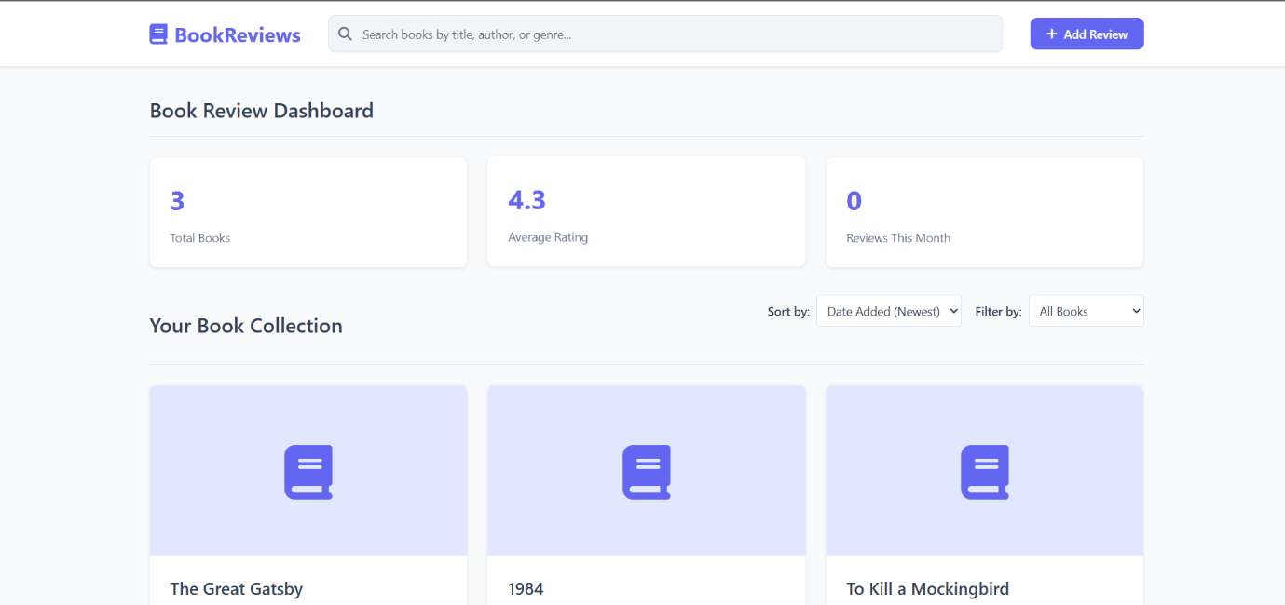**OUTPUT:**

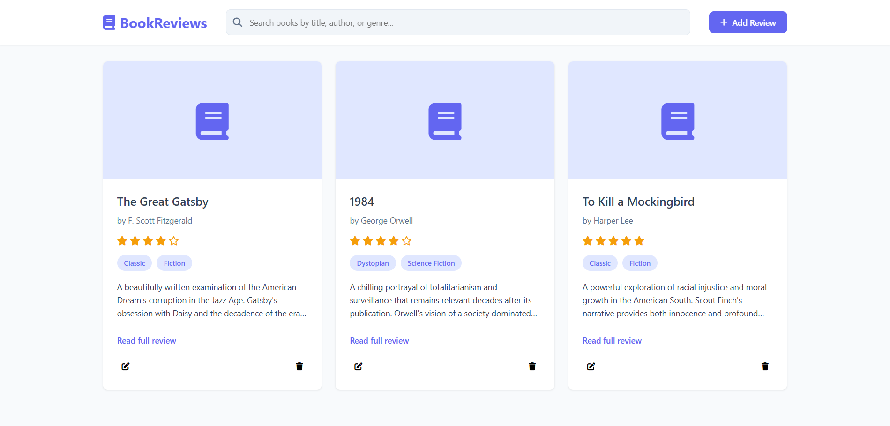

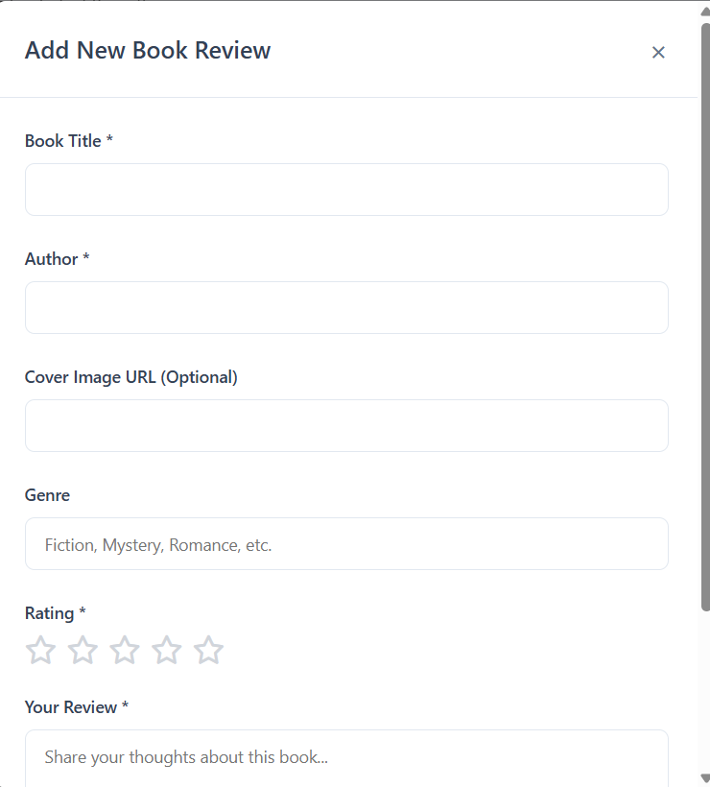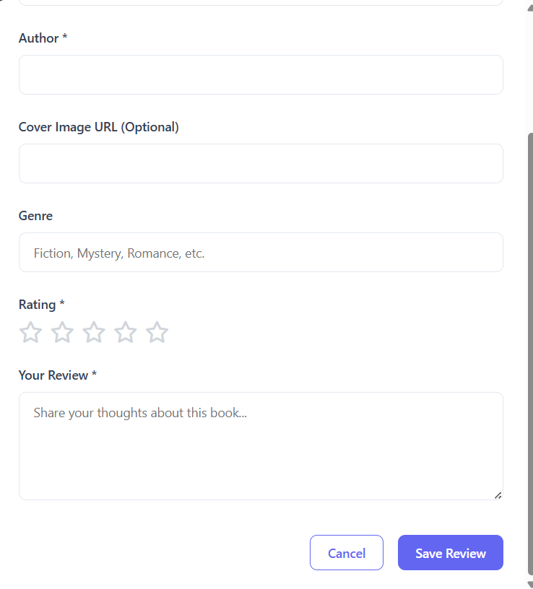

**RESULT:**

Thus a book review system is implemented using php with mySQL.